Final Project – IST 664

Classification of Kaggle Movie Reviews



*Students:*  *Professor:* Michael Larche

Anjana Sowmya Puvvada ---- 678858700

Nikitha Chandana ------------- 261701620

Prathyusha Murala ------------ 221363796

Table of Contents

Introduction 4

Data Description 5

Reading the Train Data 6

Tokenization and Filtering 7

a. Pre-processing documents 7

b. Retrieving words/tokens 8

Creating Feature Sets 9

a. Bag of Words (BOW)/Unigram features 9

b. Sentiment Lexicons 9

c. Negation word features: 11

d. POS features 12

e. Bigram Features 13

f. Trigram Features 14

g. Combined feature sets 15

Naïve Bayes Classifier - NLTK 16

a. Without Pre-processing 16

b. After Pre-processing 17

c. Sentiment Lexicon Features 17

d. NOT features 18

e. POS Features 18

f. Bigram features 19

g. Trigram features 19

h. Combined feature set 20

Results & Observations: 21

Logistic Regression- Scikit Learn 22

a. Without Pre-processing 23

b. After Pre-processing 23

c. Sentiment Lexicon 24

d. NOT Features 24

e. POS Features 25

f. Bigram Features 25

g. Trigram Features 26

h. Combined Features 26

Results & Observations: 27

Support Vector Machines- Scikit Learn 28

a. Without Pre-processing 29

b. After Pre-processing 29

c. Sentiment Lexicon 30

d. NOT Features 30

e. POS Features 31

f. Bigram Features 31

g. Trigram Features 32

h. Combined Features 32

Results & Observations: 33

Decision Tree Classifier – Scikit Learn 34

a. Without Pre-processing 35

b. After Pre-processing 35

c. Sentiment Lexicon 36

d. NOT Features 36

e. POS Features 37

f. Bigram Features 37

g. Trigram Features 38

h. Combined Features 38

Results & Observations: 39

Experiments Summary 40

Advanced Task 42

Results & Observations: 44

Conclusion 45

Lessons Learned 45

Work Distribution 46

# Introduction

The primary objective of this project is to classify and predict the sentiment of movie reviews. The scale of sentiment classification is 0-4 with equal intervals.

The details of scale for sentiment follows:

|  |  |
| --- | --- |
| Classification Scale | Sentiment |
| 0 | Negative |
| 1 | Strong Negative |
| 2 | Neutral |
| 3 | Positive |
| 4 | Strong Positive |

This dataset was produced for the Kaggle competition, described [here.](https://www.kaggle.com/c/sentiment-analysis-on-movie-reviews) which uses data from the sentiment analysis by Socher et al, detailed at this [web site.](http://nlp.stanford.edu/sentiment/) The data was taken from the original Pang and Lee movie review corpus based on reviews from the Rotten Tomatoes web site. Socher’s group used crowd-sourcing to manually annotate all the subphrases of sentences with a sentiment label ranging over: “negative”, “somewhat negative”, “neutral”, “somewhat positive”, “positive”.

Link to Dataset: <https://www.kaggle.com/c/sentiment-analysis-on-movie-reviews>

Link to Sentiment Analysis Paper: <https://nlp.stanford.edu/sentiment/>

# Data Description

For this classification task, we're provided with two datasets: a training dataset and a testing dataset. Due to the large size of the data, we plan to utilize a subset of the training set for our analysis. This approach allows us to efficiently explore the data and develop our classification model without being overwhelmed by the computational demands of the entire dataset. By working with a representative subset, we can still extract valuable insights and develop a robust model that generalizes well to unseen data.

Training Data Metadata: (Size = 156,060 entries)

|  |  |
| --- | --- |
| Column name | Description |
| PhraseId | Represents id number of a phrase |
| SentenceId | Represents id for each sentence |
| Column_name | Description |
| Phrase | Represents the review for movie |
| Phrase Sentiment | Represents the sentiment for each review |

Testing Data Metadata: (Size = 66,292 entries)

|  |  |
| --- | --- |
| Column name | Description |
| PhraseId | Represents id number of a phrase |
| SentenceId | Represents id for each sentence |
| Phrase | Represents the review for movie |

Important to note is that the test data lacks sentiment labels, making the sentiment column our target label for prediction. Consequently, throughout our analysis, features will encompass Phraseid, SentenceID, and Phrase, while Sentiment serves as the target label for our classification task.

# Reading the Train Data

The first step is to read the data into python environment. This is done using the code below:

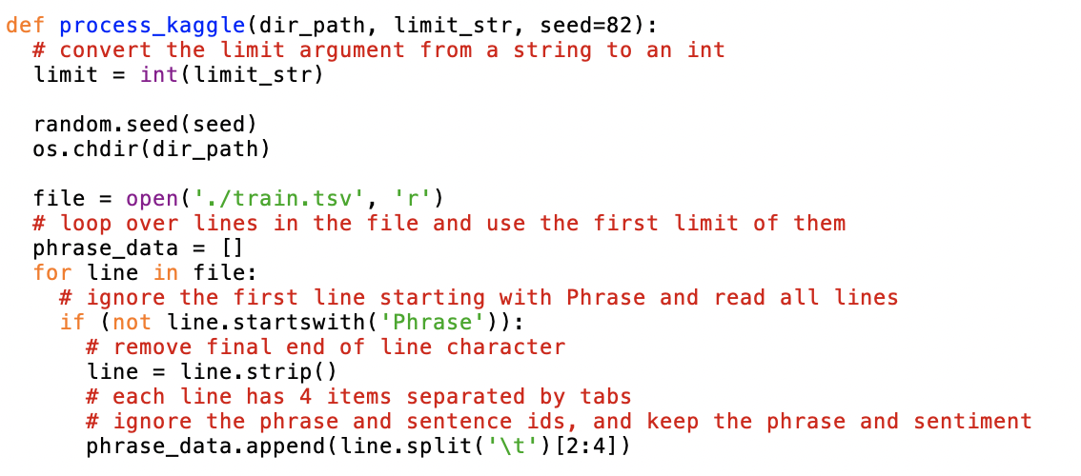 We're developing a function to iterate through each line of the CSV file and populate a list called 'phrasedata'. Additionally, we've incorporated an option to limit the number of rows included in the loaded data. This flexibility is valuable when conducting analysis on a subset of instances due to computational constraints, although the ideal approach for classification and prediction tasks is to utilize the entire dataset. Despite these limitations, we endeavored to execute our analysis on the complete dataset.

# Tokenization and Filtering

After loading the entire training dataset, the next step involves tokenizing each word within a phrase to facilitate further analysis. Utilizing these tokenized phrases, we can generate various feature sets tailored to our needs. Below is the code developed for this purpose:

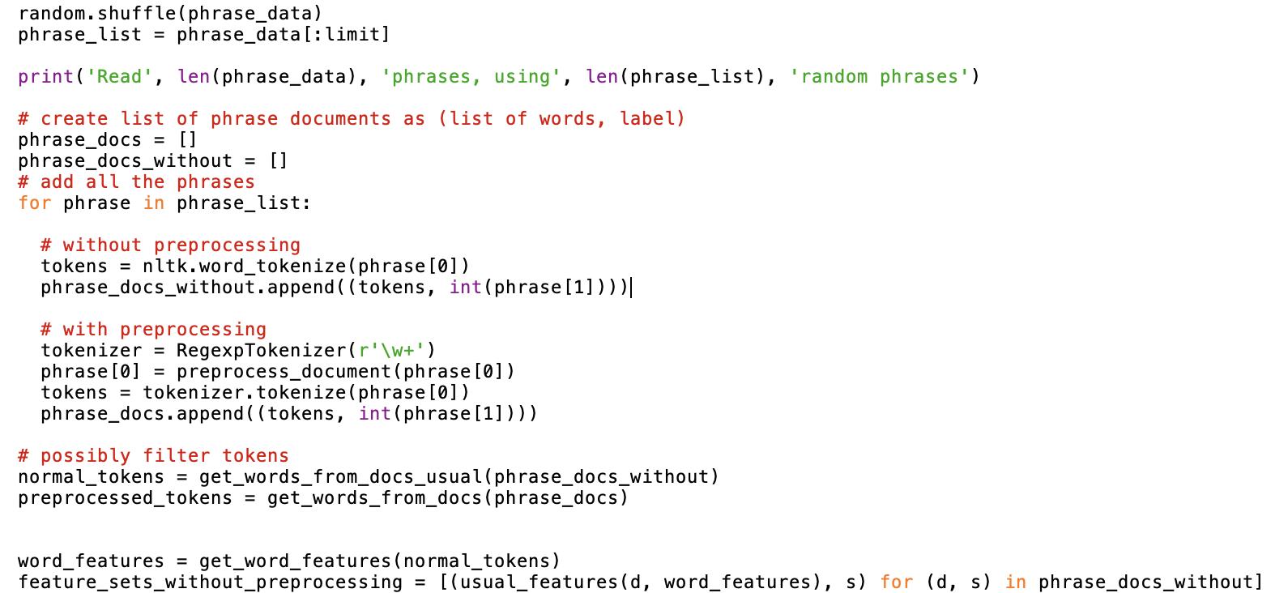

The code demonstrates the utilization of NLTK's `tokenize` function for phrase tokenization. Before tokenization, a Pre-processing step is applied to the tokens using the regular expression '\w+', which matches any alphanumeric character with underscores occurring one or more times. After tokenization, two distinct lists are created: 'normaltokens', containing word phrases without any filtering, and 'preprocessedTokens', containing word phrases after applying the filtering process.

We have defined the following functions to perform the tokenization and filtering process:

## Pre-processing documents

This function splits each phrase into individual lines and converts them into lowercase. Subsequently, lowercase lines undergo regular expression processing to remove words with punctuation marks, and the remaining words are stored in a list named 'word_list'. Following this, the list is filtered to remove any stop words, resulting in a new list called 'final_word_list'.

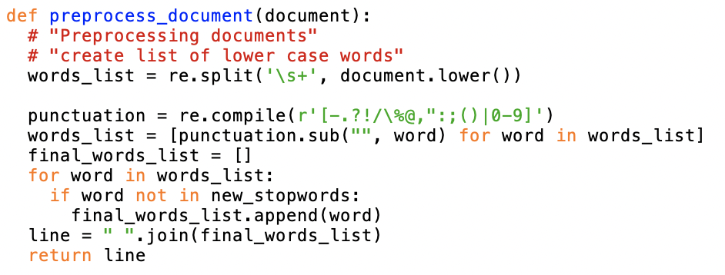

## Retrieving words/tokens

There are three functions defined in this code. The first function returns list which contains tokens/words from the documents where the length is greater than 3. The second function returns a list of all words with corresponding sentiment. The third function returns all lines from the tokens.

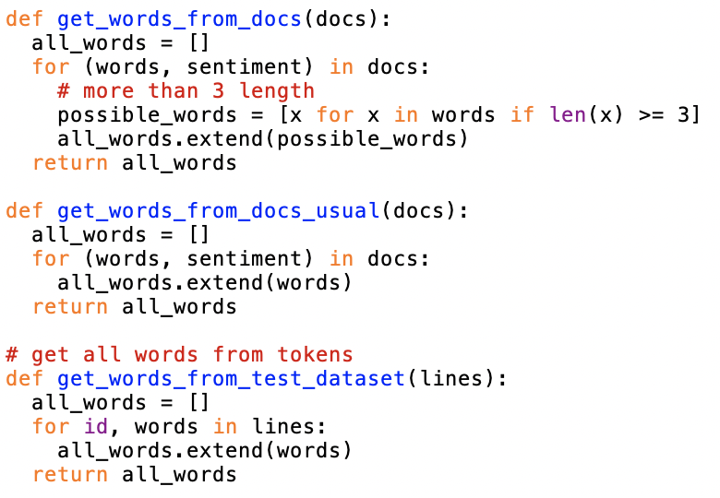

# Creating Feature Sets

The next key step in classification tasks in NLP is to create features from raw tokens. We had to define multiple features generating functions such as bag of words (BOW), bigrams, sentiment lexicons, negation words, POS tag features etc. Let us try to understand each of these functions,

## Bag of Words (BOW)/Unigram features

For creating unigrams we defined two different functions. The first function creates a list of most repeated 200 words from the *‘wordlist’* which has processed tokens. The second function creates unique list of words from the documents and returns them as features.

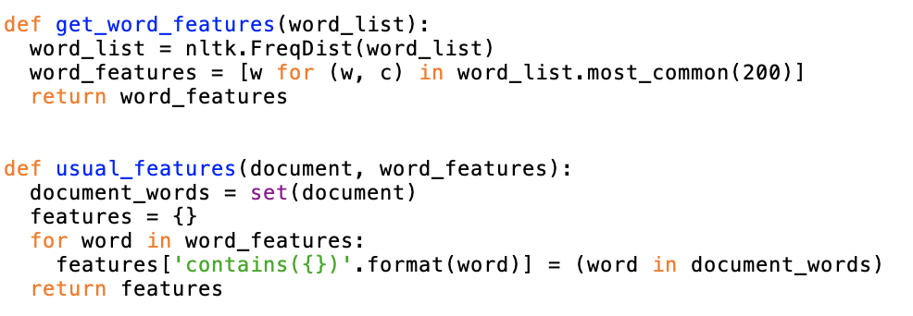

Once the functions are defined, we have applied these functions on the filtered phrases, saved them into CSV files and calculated accuracy of the classifier based on those files.

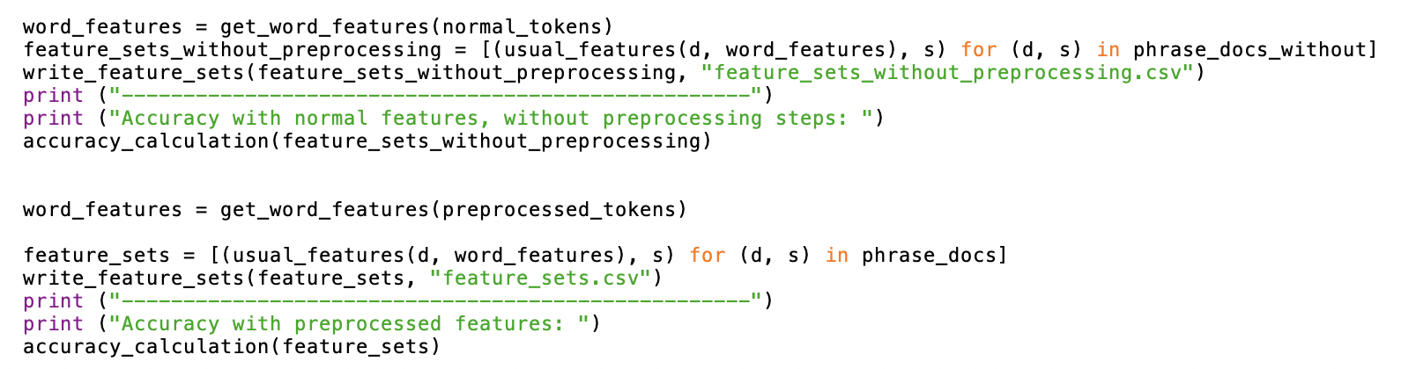

## Sentiment Lexicons

We began by reading in the subjectivity words from the lexicon file created by Janyce Wiebe and her team at the University of Pittsburgh in the MPQA project. These words, often used as features themselves or in conjunction with other information, were utilized to create two features: positivecount and negativecount. The `readSubjectivity` function, copied and pasted from the Subjectivity.py module provided by Professor, is responsible for creating a Subjectivity Lexicon represented as a dictionary. Each word in the lexicon is mapped to a list containing its strength and polarity.

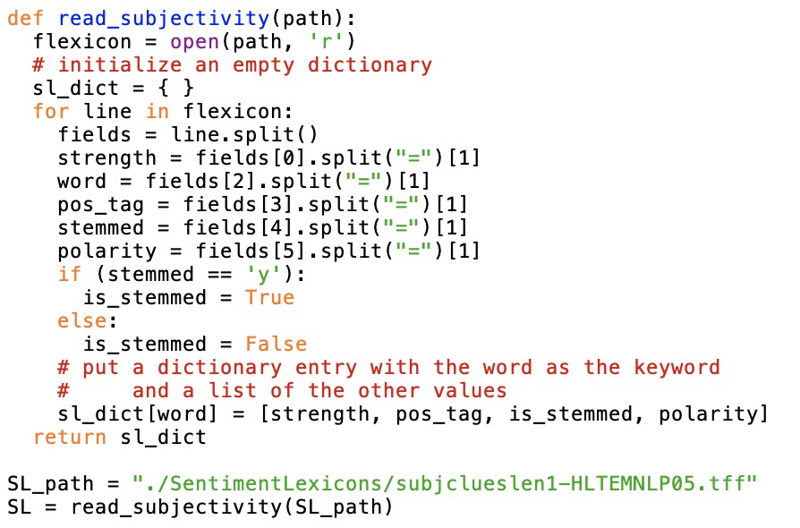

Subsequently, a feature extraction function is developed, containing all the word features as before, in addition to the two new features: positivecount and negativecount. These features will hold counts of all the positive and negative subjectivity words present in each document, where each weakly subjective word is counted once and each strongly subjective word is counted twice.

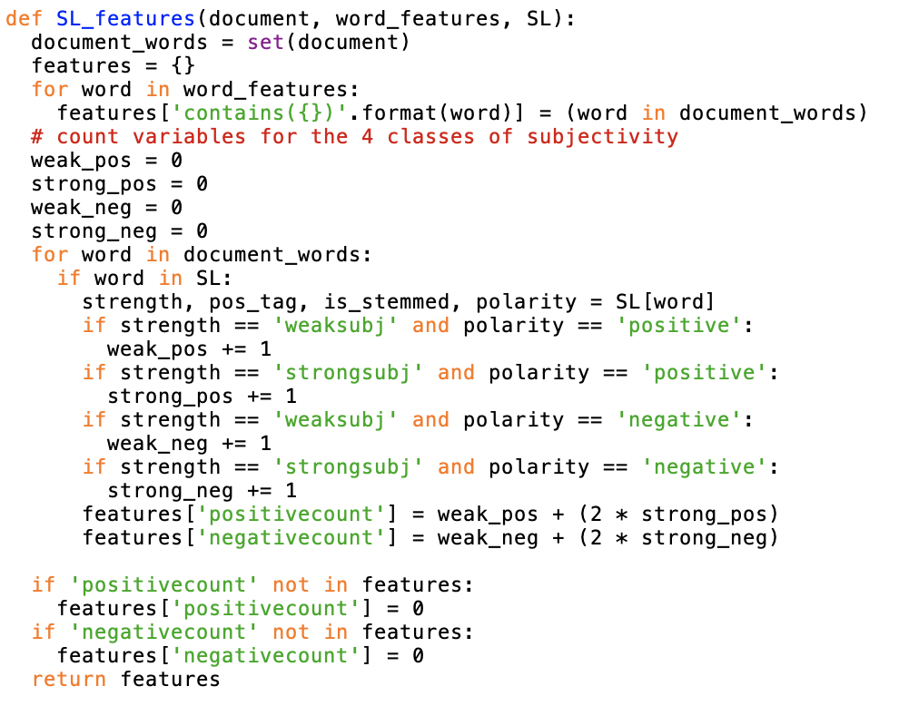

Once the functions are defined, we have applied these functions on the filtered phrases, saved them into CSV files and calculated accuracy of the classifier based on those files.

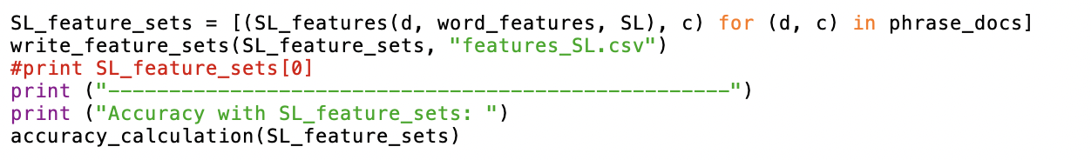

## Negation word features:

Incorporating the negation of opinions is crucial for sentiment classification. Following a simple strategy outlined by the professor in Lab-10, we identified negation words such as 'not', 'never', and 'no', as well as contractions like 'doesn't', using a predefined list. For instance, in the first document, words like 'don't' are recognized as negation indicators.

In this strategy, upon encountering a negation word, we negate the following word in the document. This approach contrasts with others that either negate all words up to the next punctuation mark or employ syntax to determine the scope of the negation.

During feature extraction, we traversed the document's words sequentially, adding them as features. If a word follows a negation word, we modified the feature to reflect the negated word.

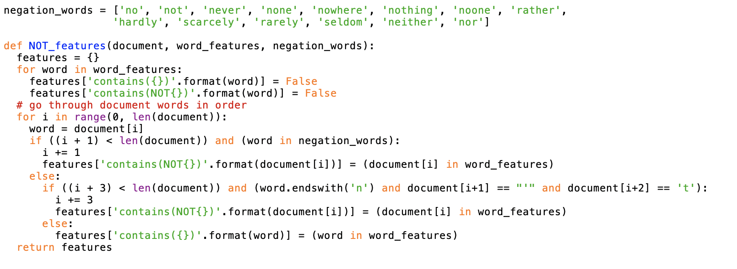

Once the functions are defined, we have applied these functions on the filtered phrases, saved them into CSV files and calculated accuracy of the classifier based on those files.

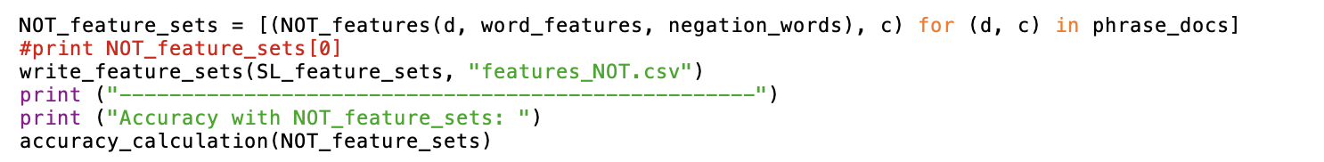

## POS features

We approached this classification task by incorporating part-of-speech (POS) tag features, which is particularly suitable for shorter units of classification such as sentence-level or shorter social media texts like tweets. The primary method of utilizing POS tagging information is by including counts of various types of word tags. These counts serve as features in our classification model, allowing us to capture syntactic patterns that may be indicative of sentiment.

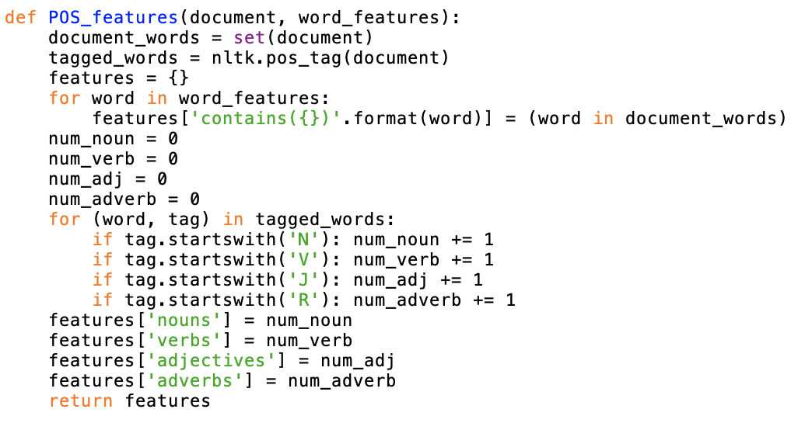

Once the functions are defined, we have applied these functions on the filtered phrases, saved them into CSV files and calculated accuracy of the classifier based on those files.

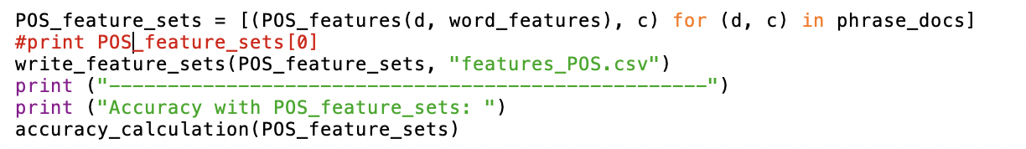

## Bigram Features

We've extracted high-frequency bigram features by filtering out special characters and selecting bigrams based on their frequency. Using the `nbest` function, we obtained the top-scoring bigrams, specifying the desired number in both frequency and other scoring measures.

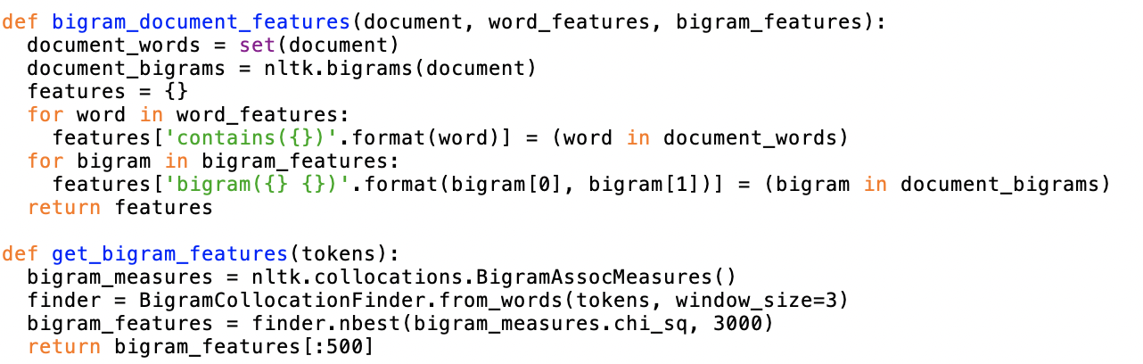

Once the functions are defined, we have applied these functions on the filtered phrases, saved them into CSV files and calculated accuracy of the classifier based on those files.

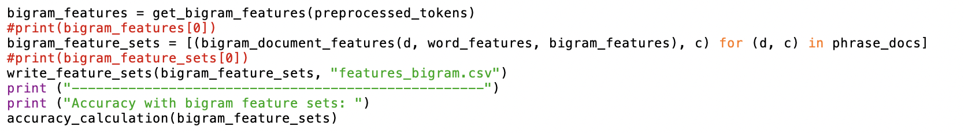

## Trigram Features

We've extracted high-frequency Trigram features by filtering out special characters and selecting trigrams based on their frequency. Using the `nbest` function, we obtained the top-scoring trigrams, specifying the desired number in both frequency and other scoring measures.

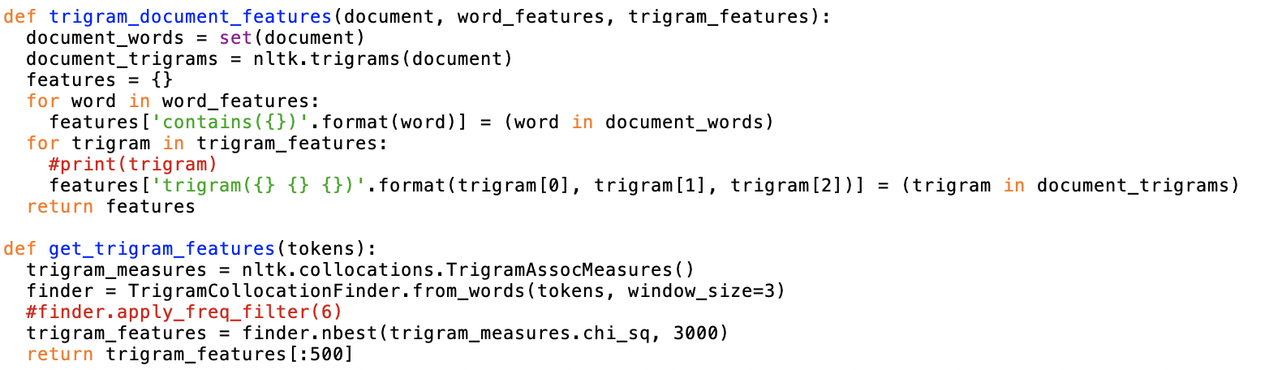

Once the functions are defined, we have applied these functions on the filtered phrases, saved them into CSV files and calculated accuracy of the classifier based on those files.

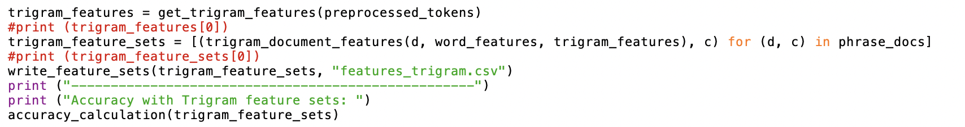

## Combined feature sets

We devised a new function to amalgamate various feature sets, including Sentiment Lexicons, Bigram features, and unigram features, based on the accuracies calculated in subsequent steps and the most informative features. Below is the code implementing this functionality:

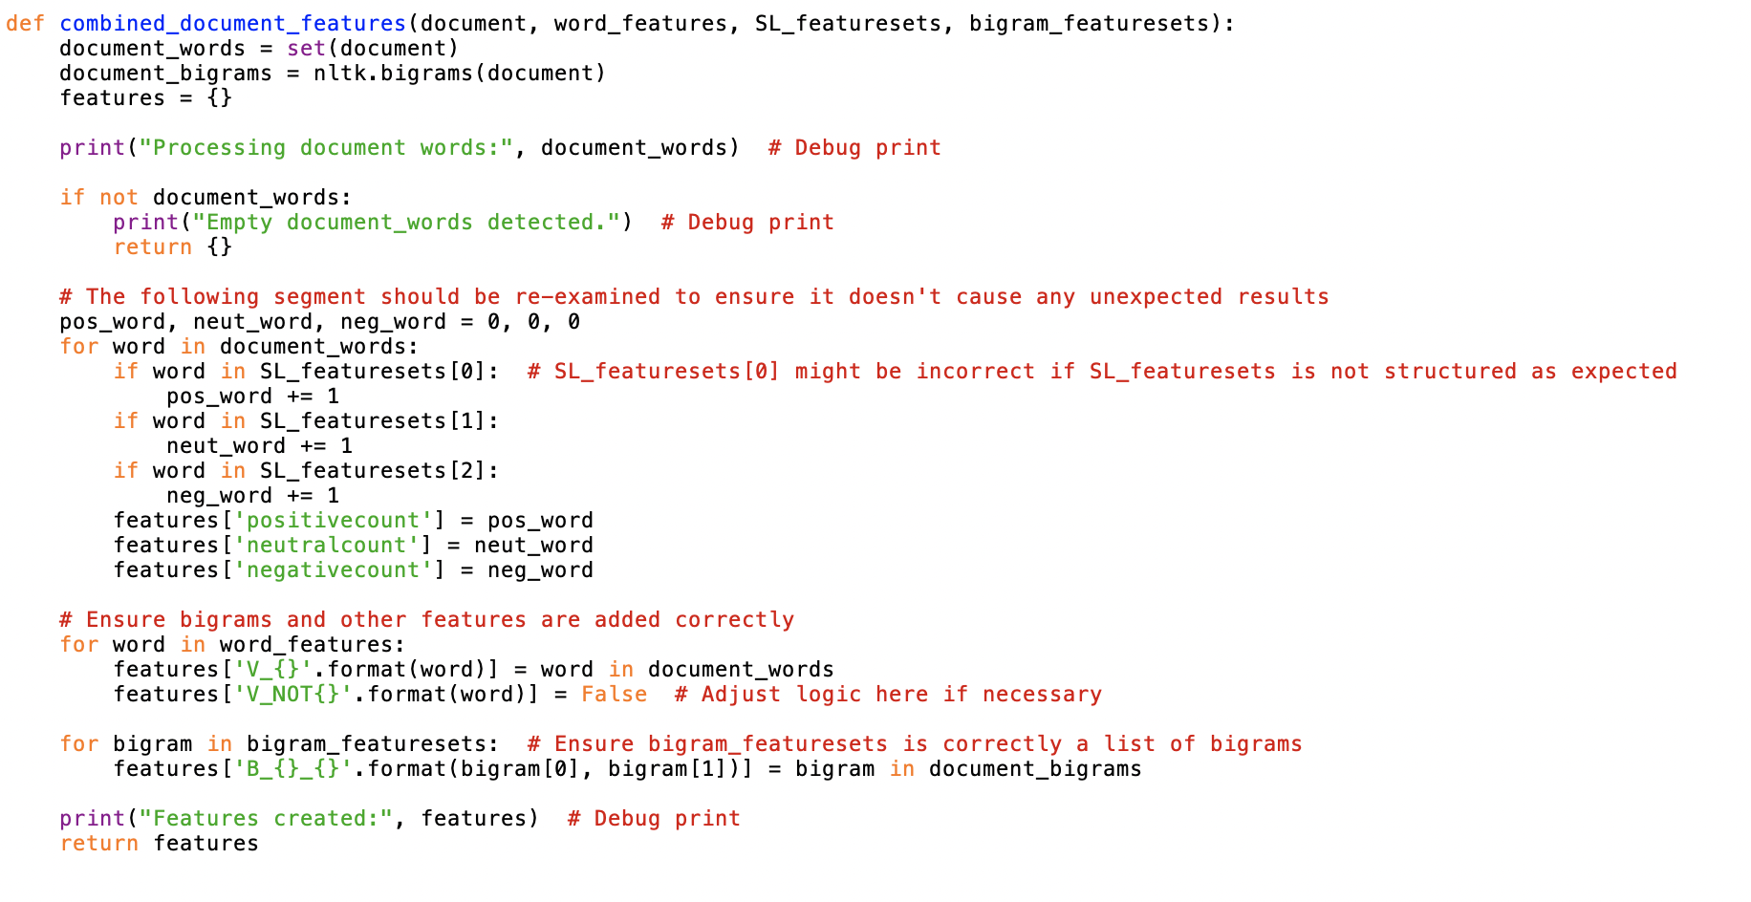

Once the functions are defined, we have applied these functions on the filtered phrases, saved them into CSV files and calculated accuracy of the classifier based on those files.

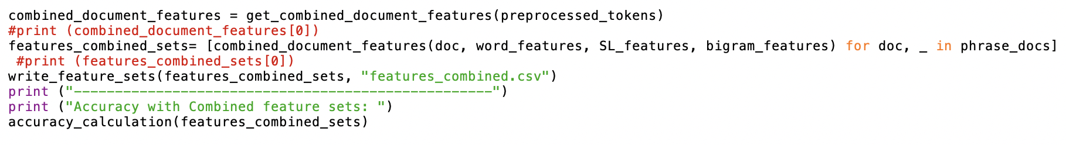

# Naïve Bayes Classifier - NLTK

In this section we will discuss the classifier’s accuracy obtained for each of the feature sets created by running the above functions on a random sample of 100, 300, 500 & 700 to test accuracies.

The below is the code used for calculating accuracy of the classifier:

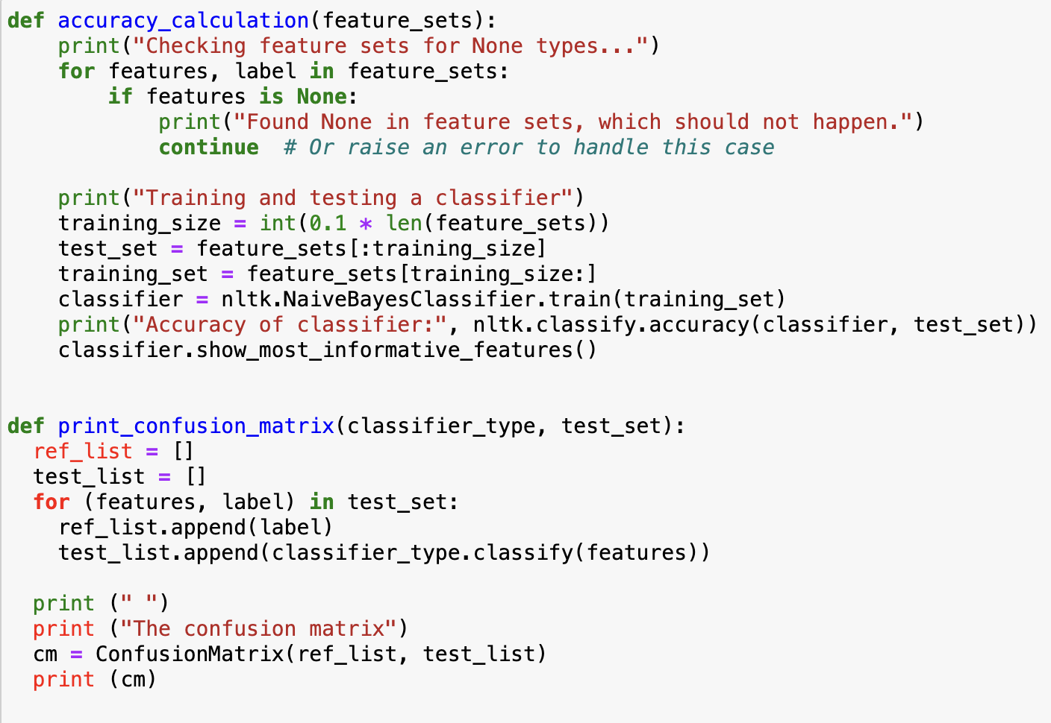

## Without Pre-processing

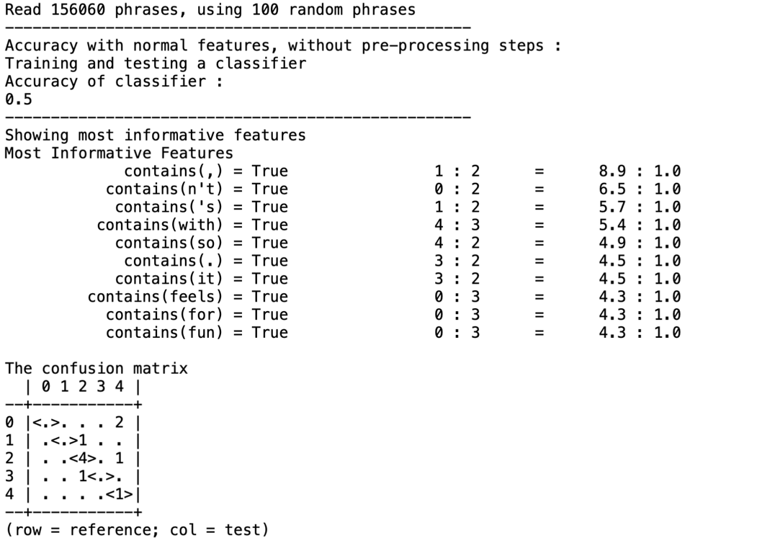

## After Pre-processing

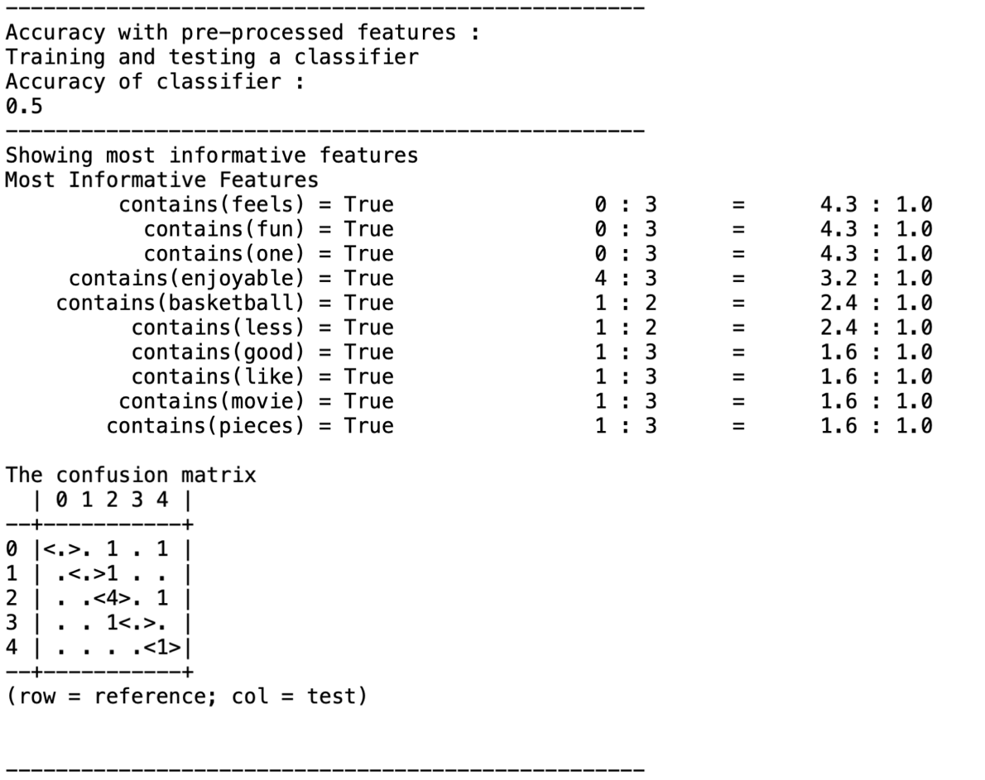

## Sentiment Lexicon Features

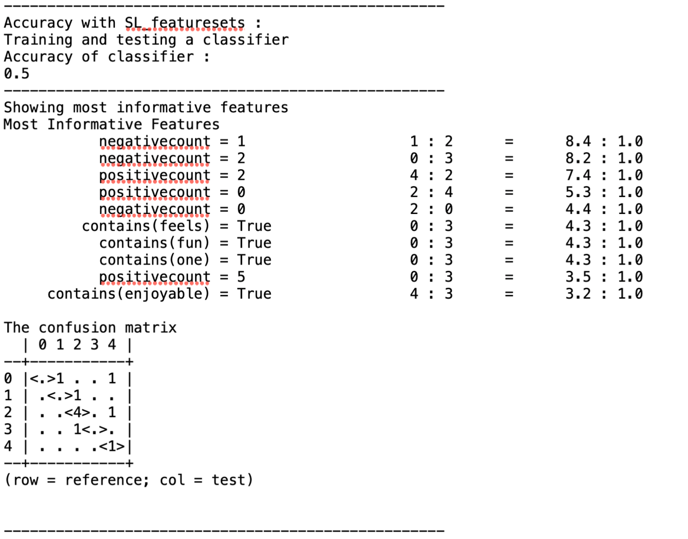

1. NOT features

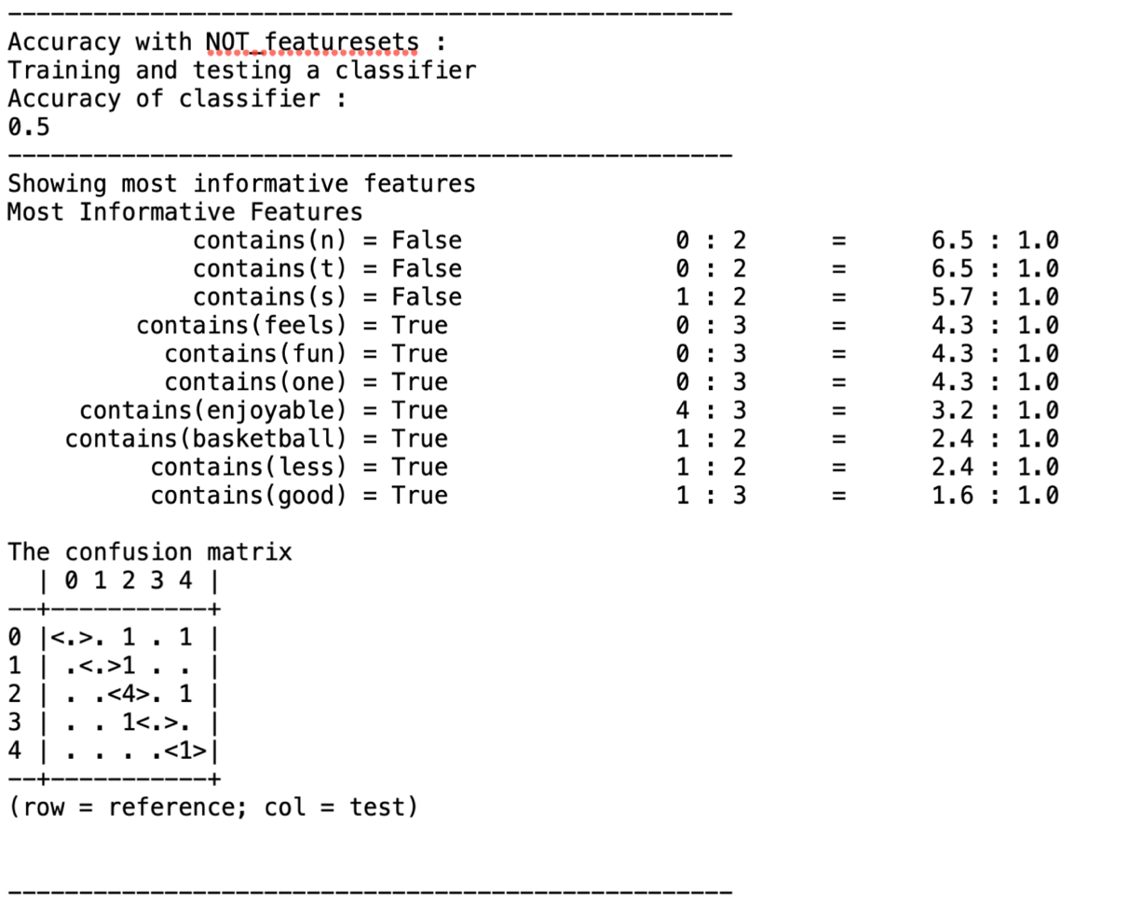

## POS Features

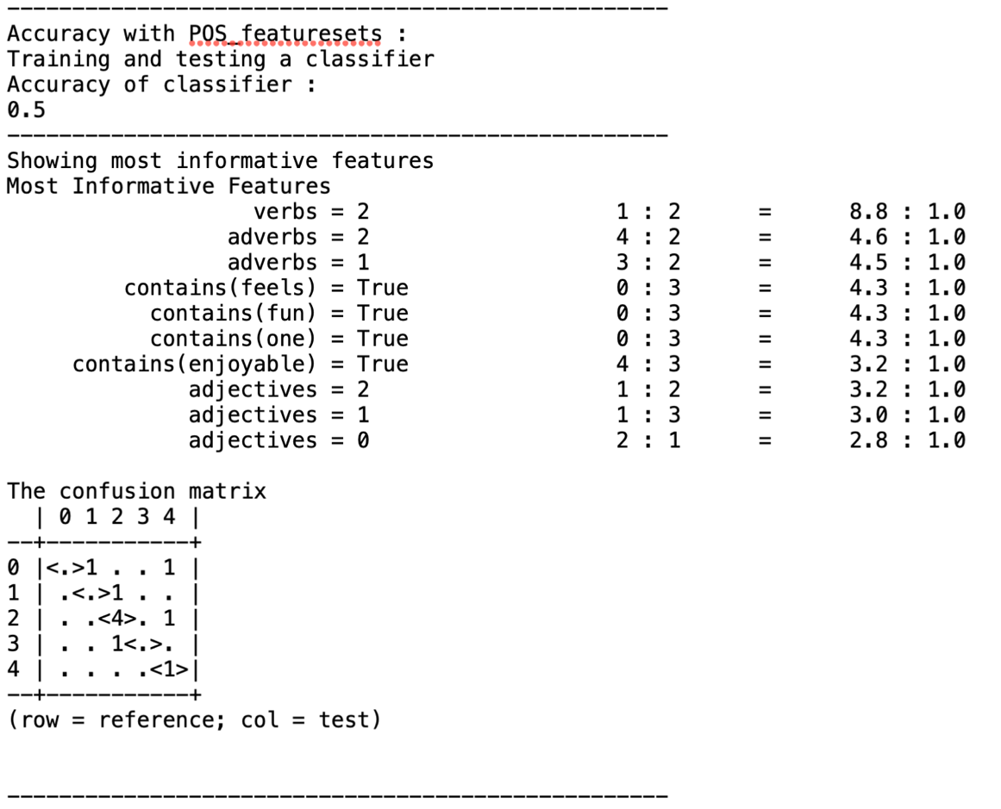

## Bigram features

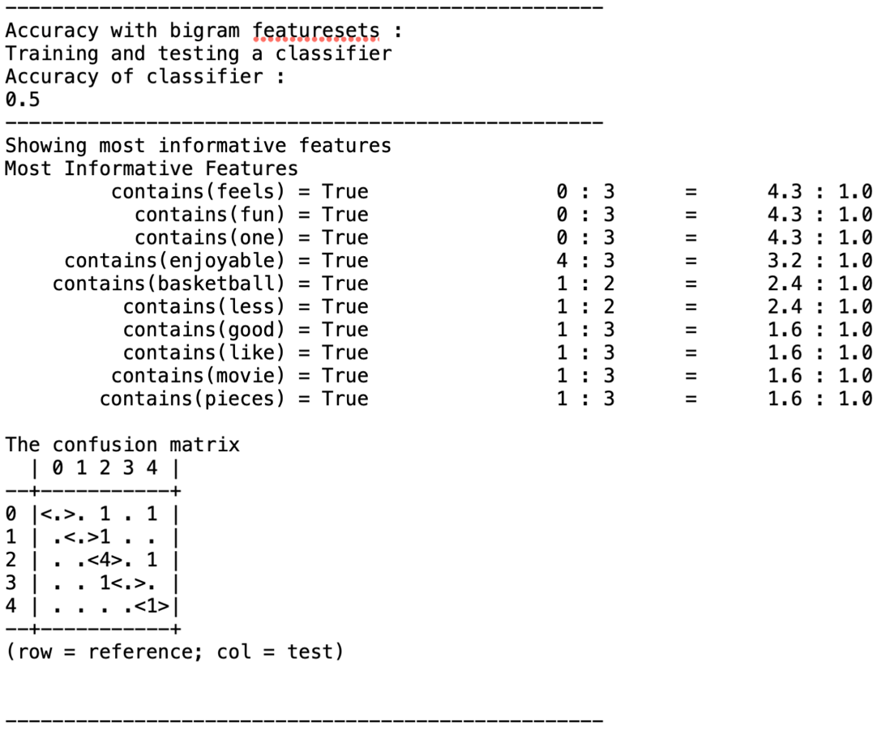

## Trigram features

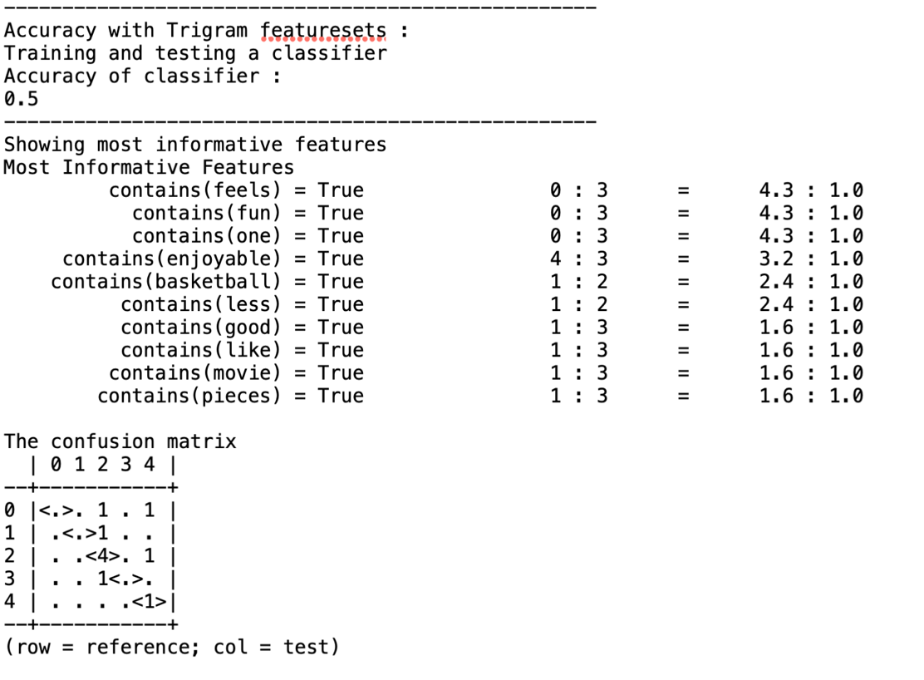

## Combined feature set

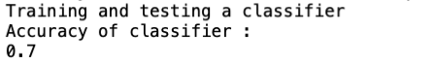

The first most Informative Feature: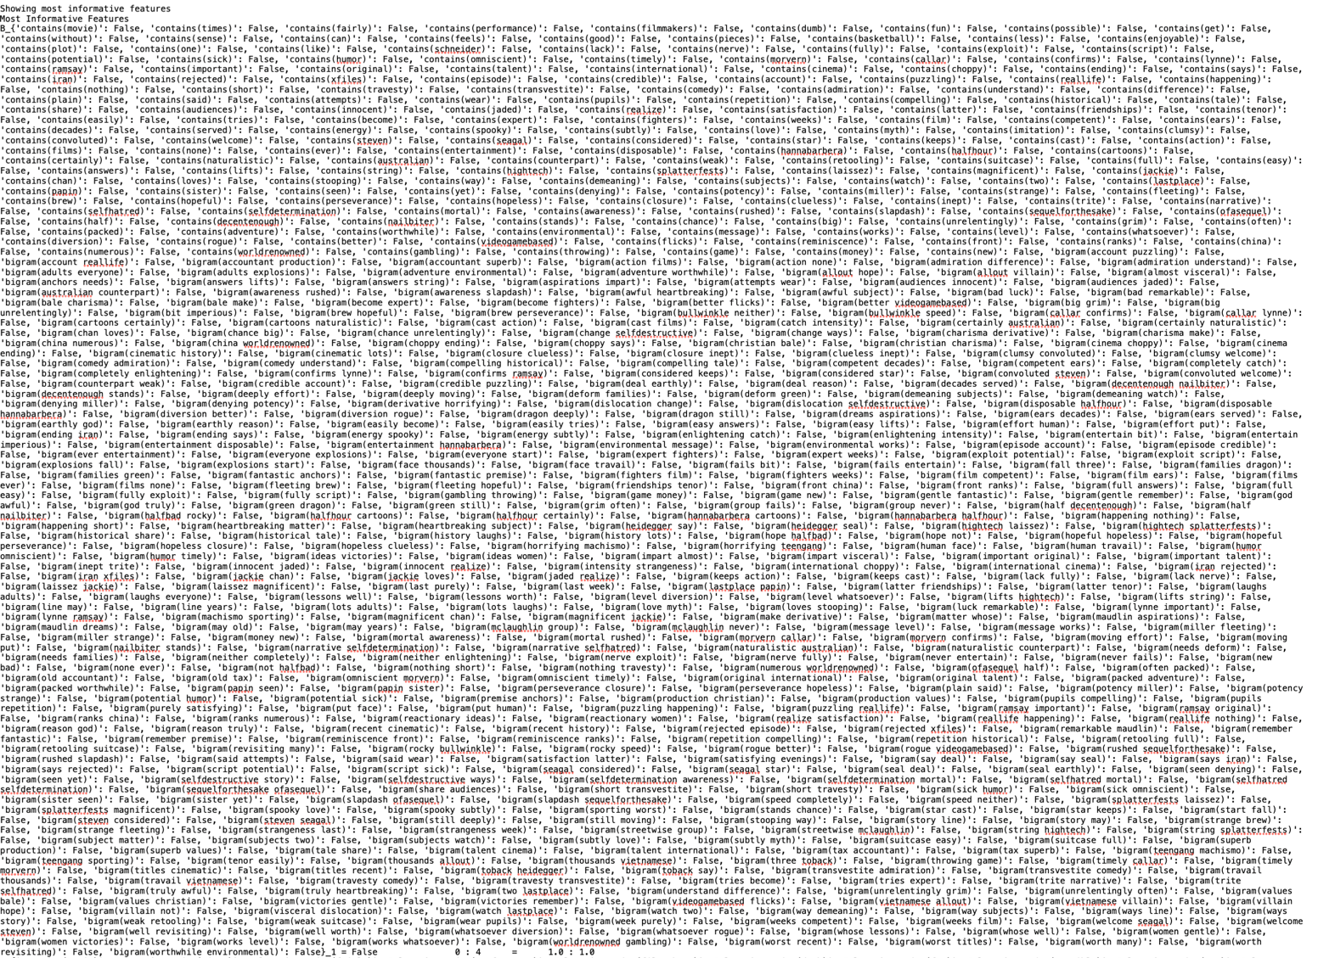

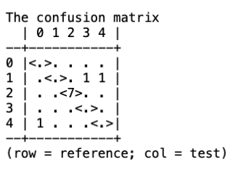

## Results & Observations:

We conducted multiple runs by randomly shuffling and selecting 100 phrases from the corpus to calculate accuracy for our features. Due to the randomness of the selection process, the accuracies varied across different runs. The below are the average accuracies observed over multiple iterations.

|  |  |
| --- | --- |
| Naïve Bayes Accuracy Table | |
| Without Pre-Processing | 50% |
| With Pre-processing | 50% |
| Sensitivity Lexicon | 52% |
| Negative words | 50% |
| Parts of speech | 48% |
| Bigram | 50% |
| Trigram | 50% |
| Combined | 70% |

Among all features, the combined feature set yielded the highest accuracy. This heightened accuracy may stem from capturing the non-linearity in the data through the creation and integration of multiple features, thereby maximizing the learning potential of the algorithm.

# Logistic Regression- Scikit Learn

The parameters used in logistic regression are:

1. Class_weight: Weights associated with classes in the form {class_label: weight}. If not given, all classes are supposed to have weight one. The “balanced” mode uses the values of y to automatically adjust weights inversely proportional to class frequencies in the input data as n_samples / (n_classes * np.bincount(y)).
2. solver: Algorithm to use in the optimization problem.
3. Multi_class: extends logistic regression to handle multiple classes by using multiple logistic functions
4. max_iter: Maximum number of iterations taken for the solvers to converge.

For our analysis, we have used the following parameters,

|  |  |
| --- | --- |
| Parameters | Parameter value |
| Class_weight | Balanced |
| Solver | Lbfgs |
| Multi_class | Multinomial |
| max_iter | 1000 |

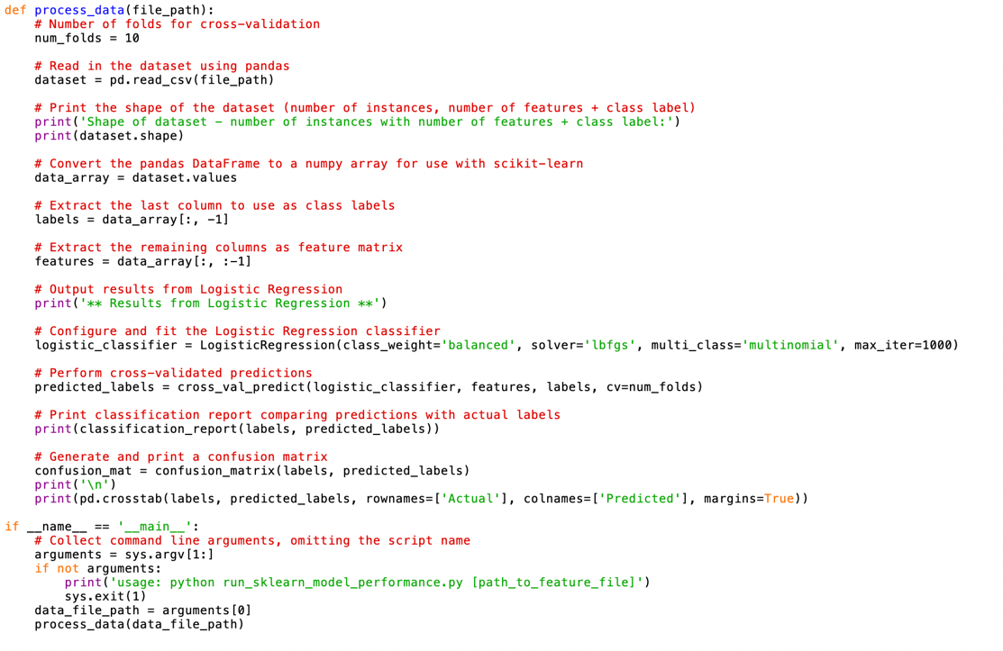

We have done experiments on different feature sets created using Logistic regression algorithm:

## Without Pre-processing

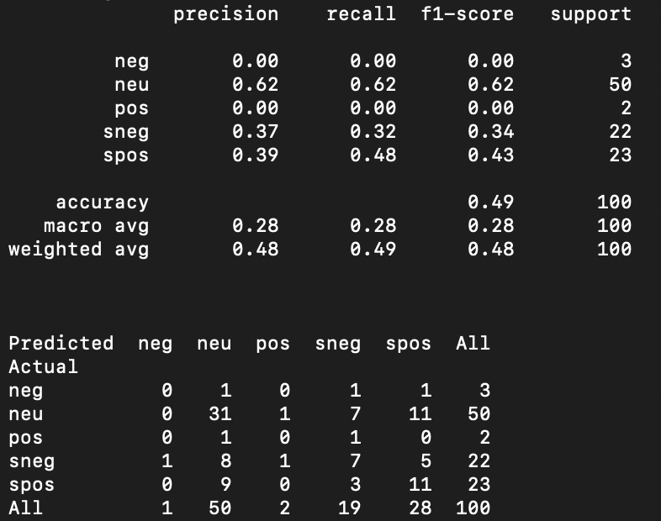

## After Pre-processing

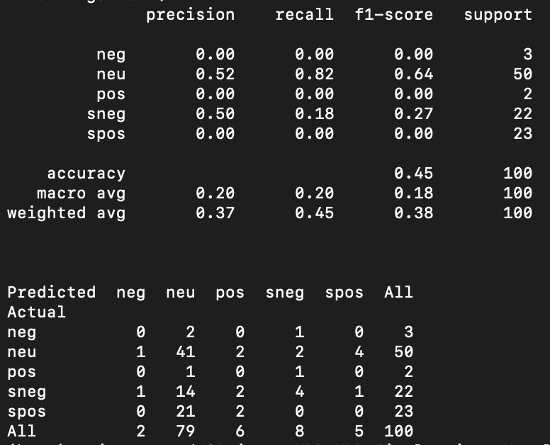

## Sentiment Lexicon

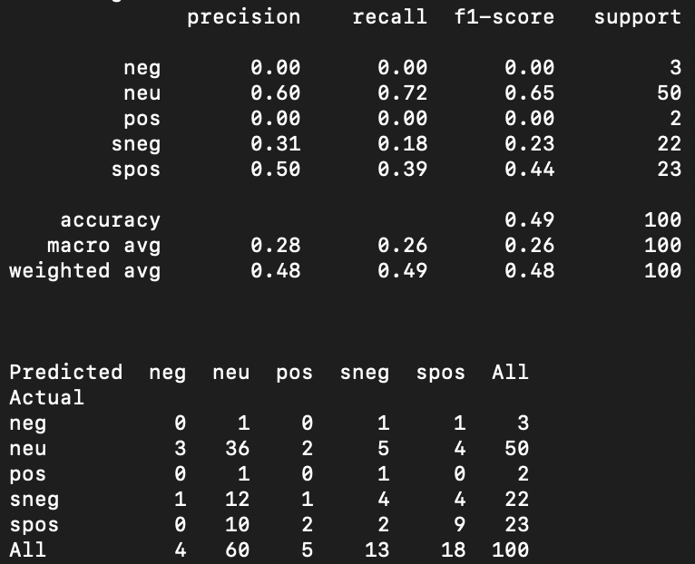

## NOT Features

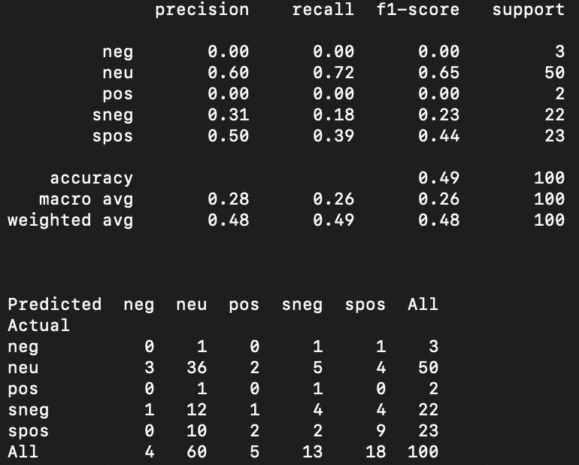

## POS Features

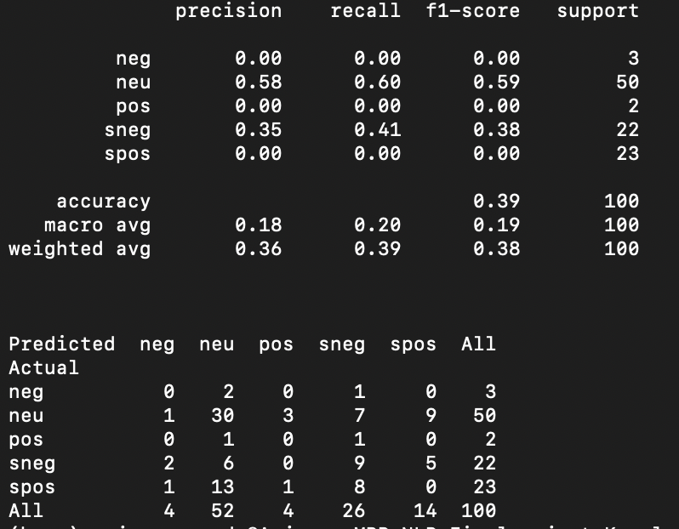

## Bigram Features

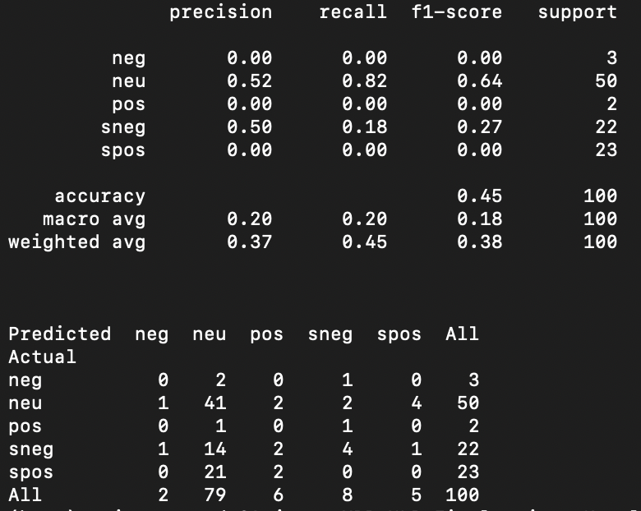

## Trigram Features

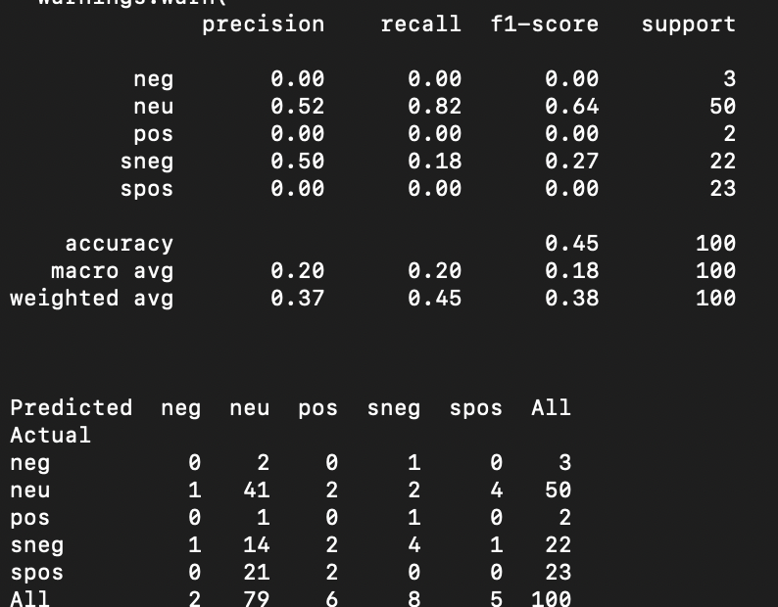

## Combined Features

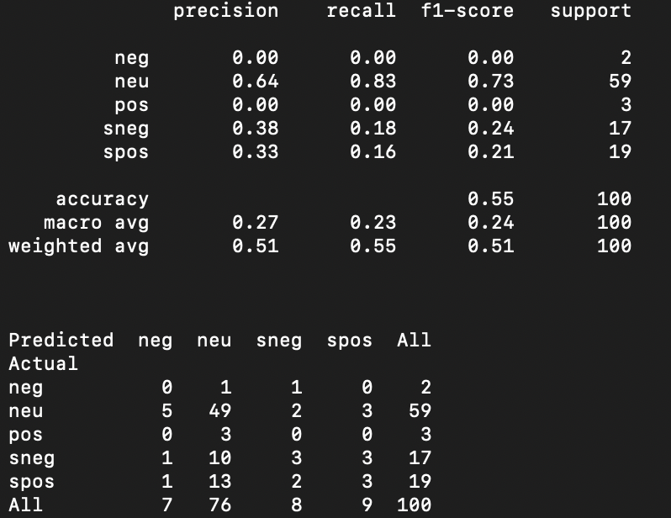

## Results & Observations:

|  |  |  |  |
| --- | --- | --- | --- |
| Logistic Regression | | | |
| Feature Name | **Precision** | **Recall** | **F1-Score** |
| Without Pre-Processing | 0.48 | 0.49 | 0.48 |
| With Pre-processing | 0.37 | 0.45 | 0.38 |
| Sensitivity Lexicon | 0.48 | 0.49 | 0.48 |
| Negative words | 0.48 | 0.49 | 0.48 |
| Parts of speech | 0.36 | 0.39 | 0.38 |
| Bigram | 0.37 | 0.45 | 0.38 |
| Trigram | 0.37 | 0.45 | 0.38 |
| Combined | 0.51 | 0.55 | 0.51 |

1. Pre-processing techniques might have led to a decrease in precision, recall, and F1-score compared to using raw data. This indicates that the pre-processing steps might have removed useful information or introduced noise into the data.

2. The logistic regression model trained on the combined feature set achieved the highest precision, recall, and F1-score among all individual feature sets. This suggests that combining multiple feature sets can enhance the model's predictive performance, likely by capturing different aspects of the data and improving its ability to generalize.

3. Parts of speech, bigram, and trigram features yielded lower precision, recall, and F1-scores compared to other feature sets. This could be due to the complexity introduced by these features, which might have made it challenging for the logistic regression model to effectively learn the underlying patterns in the data.

# Support Vector Machines- Scikit Learn

The parameters used in Support Vector Machines are,

1. Kernel: It determines the type of decision boundary used to separate data points in a higher-dimensional space.
2. Class_weight: It specifies the penalty associated with misclassification, influencing the balance between maximizing the margin and minimizing classification errors.

For our analysis, we have used the following parameters,

|  |  |
| --- | --- |
| Parameter | Parameter value |
| Kernel | Linear |
| Class_weight: | balanced |

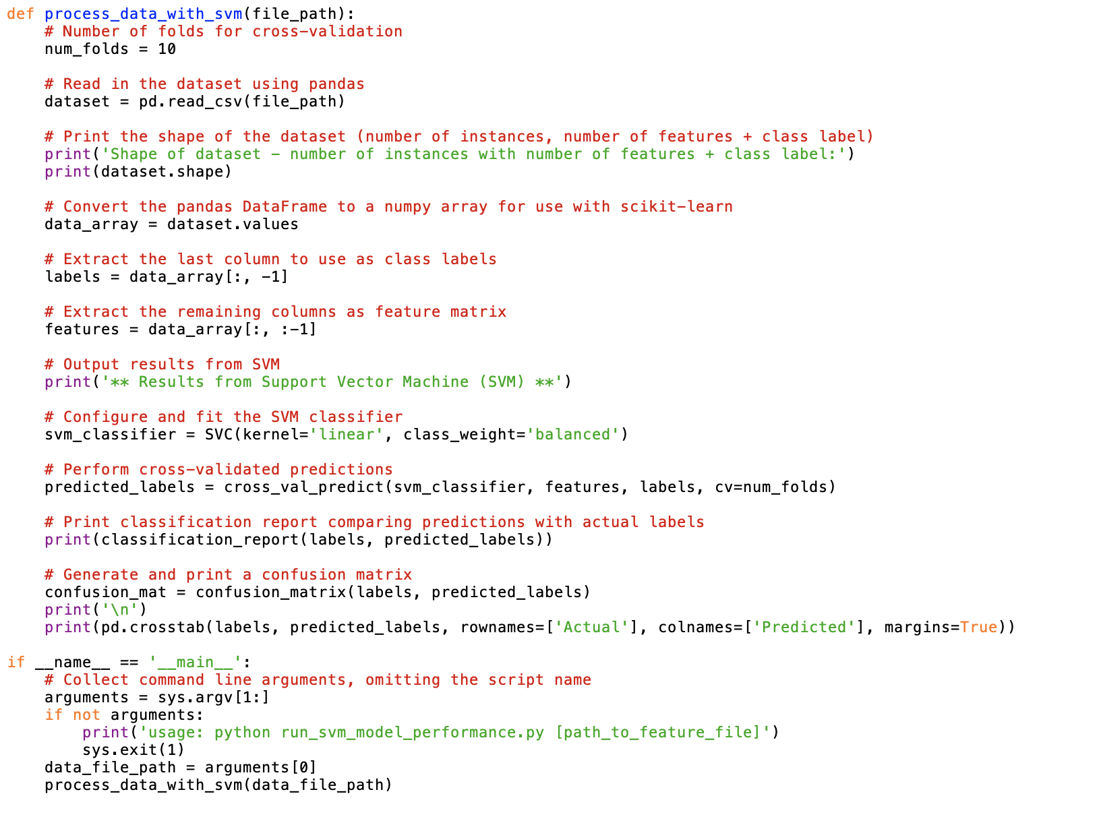

## Without Pre-processing

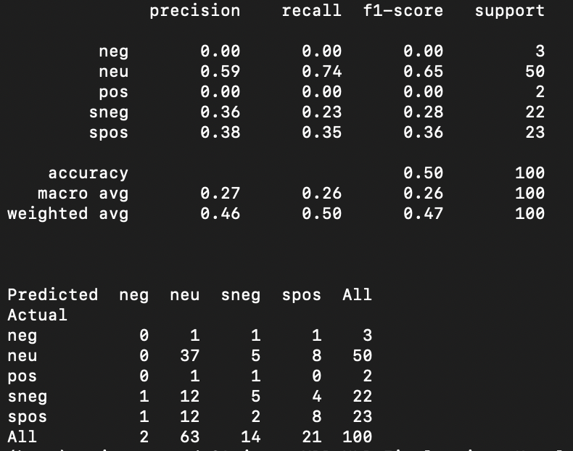

## After Pre-processing

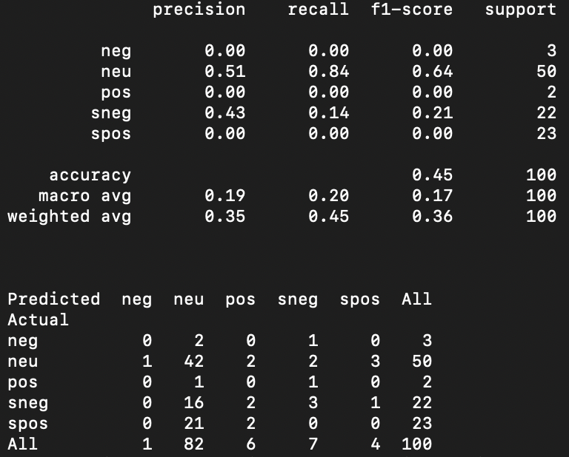

## Sentiment Lexicon

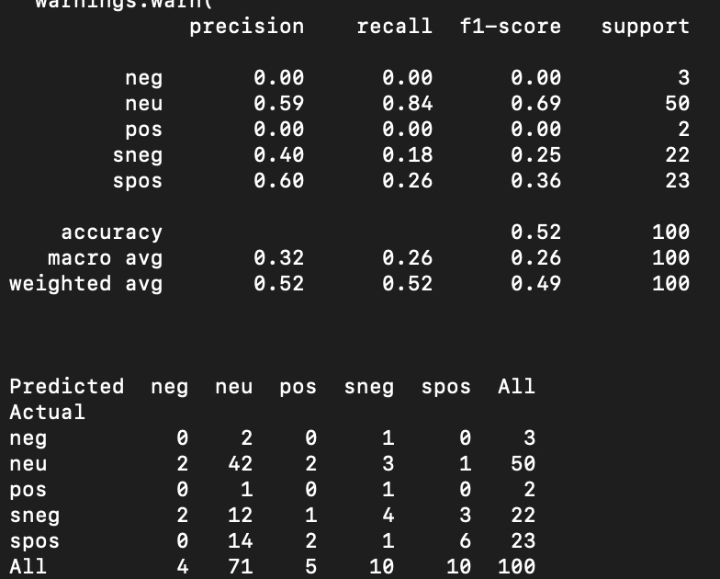

## NOT Features

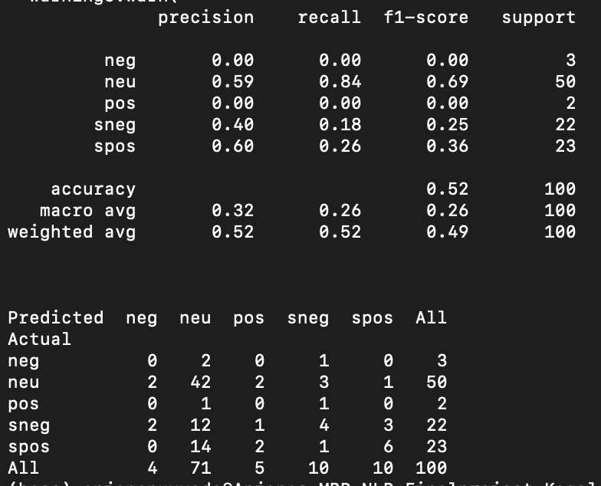

## POS Features

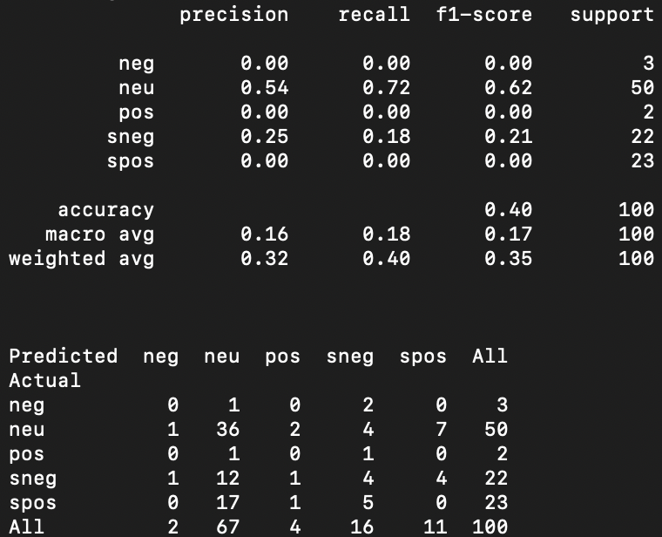

## Bigram Features

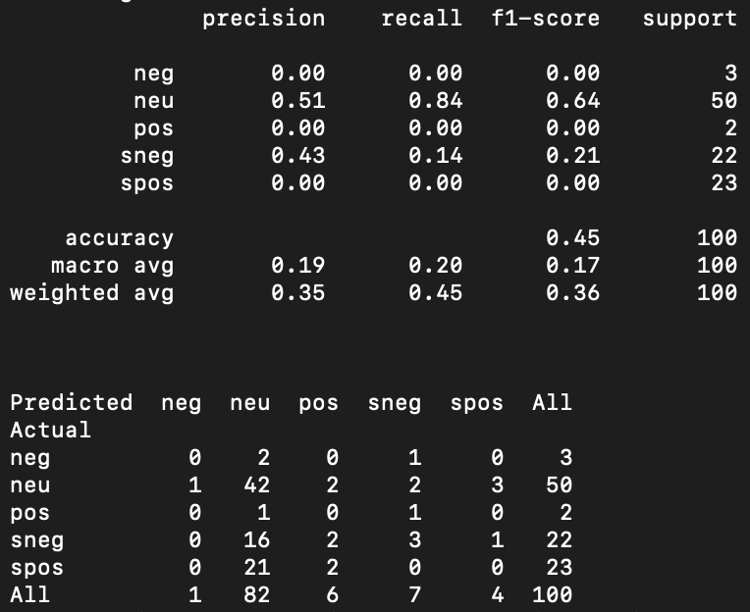

## Trigram Features

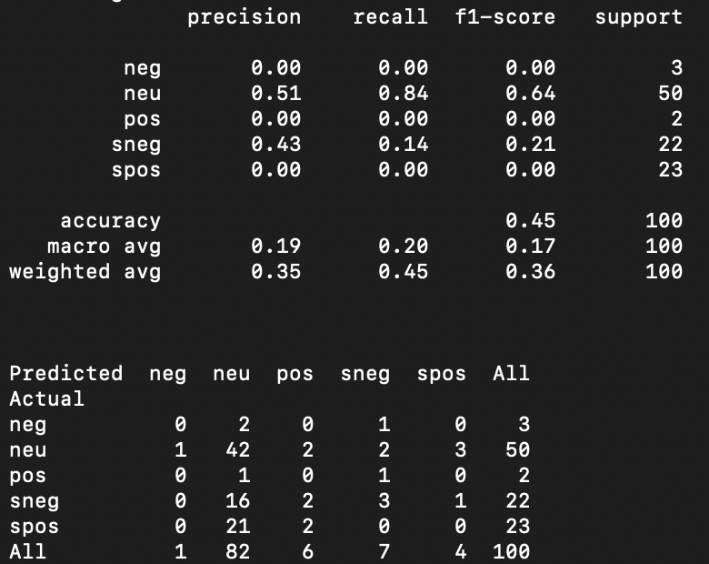

## Combined Features

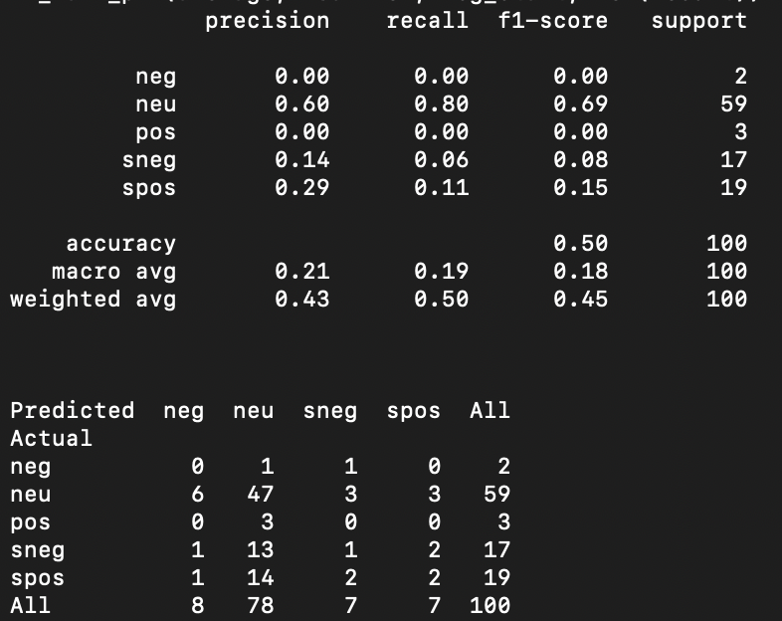

## Results & Observations:

|  |  |  |  |
| --- | --- | --- | --- |
| Support Vector Machine | | | |
| Feature Name | **Precision** | **Recall** | **F1-Score** |
| Without Pre-Processing | 0.46 | 0.50 | 0.47 |
| With Pre-processing | 0.35 | 0.45 | 0.36 |
| Sensitivity Lexicon | 0.52 | 0.52 | 0.49 |
| Negative words | 0.52 | 0.52 | 0.49 |
| Parts of speech | 0.32 | 0.40 | 0.35 |
| Bigram | 0.35 | 0.45 | 0.36 |
| Trigram | 0.35 | 0.45 | 0.36 |
| Combined | 0.43 | 0.50 | 0.45 |

1. SVM performs relatively well when using the sensitivity lexicon and negative words features, achieving higher precision, recall, and F1-score compared to other individual feature sets. This indicates that SVM is effective at leveraging sentiment-related features to classify text data.
2. SVM's ability to handle high-dimensional feature spaces makes it suitable for scenarios where feature sets are combined, as seen in the combined feature set. While the improvement in performance is not as significant as with decision trees, SVM still benefits from the richer representation of data provided by combining multiple feature sets.

# Decision Tree Classifier – Scikit Learn

The parameters used in Decision Tree Classifier are,

1. criterion: The function to measure the quality of a split. Supported criteria are “gini” for the Gini impurity and “entropy” for the information gain.
2. max_depth: The maximum depth of the tree. If None, then nodes are expanded until all leaves are pure or until all leaves contain less than min_samples_split samples.
3. min_samples_split: The minimum number of samples required to split an internal node

For our analysis, we have used the following parameters,

|  |  |
| --- | --- |
| Parameter | Parameter value |
| criterion | gini |
| max_depth | 7 |
| min_samples_split | 5 |

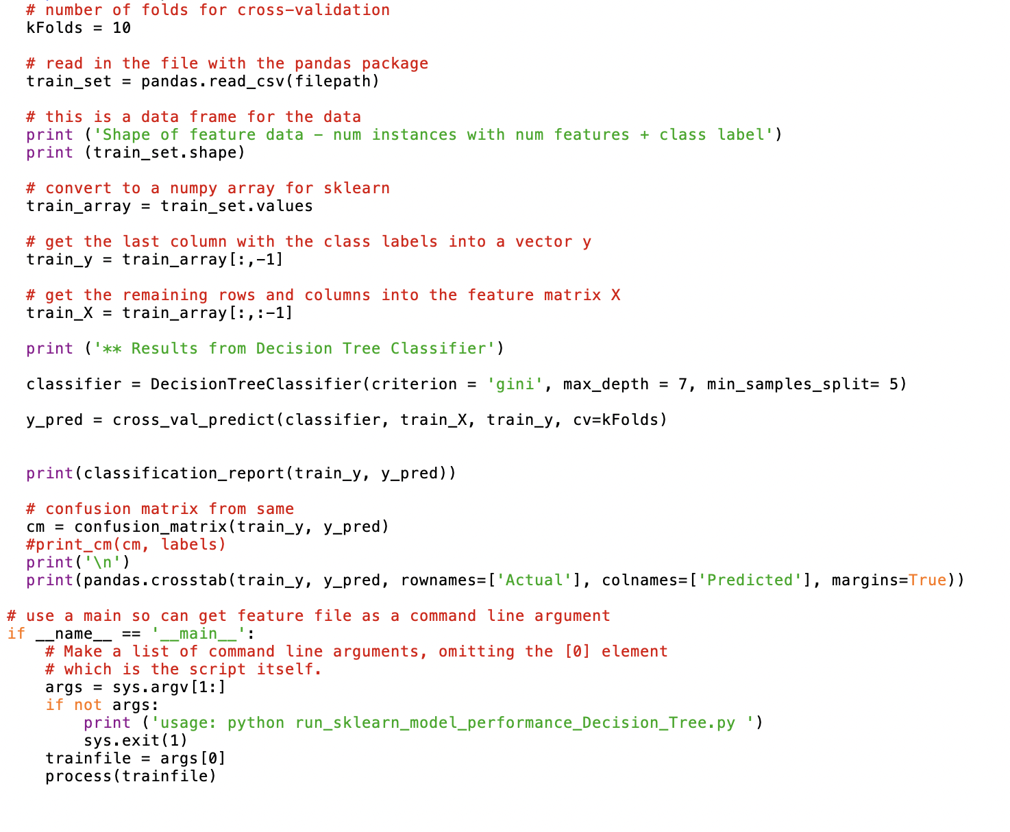

We have done experiments on different feature sets created using Decision Tree Classifier :

## Without Pre-processing

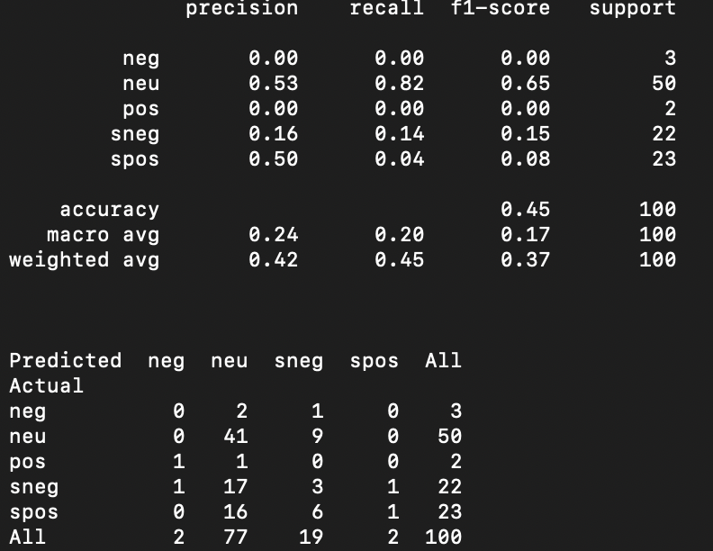

## After Pre-processing

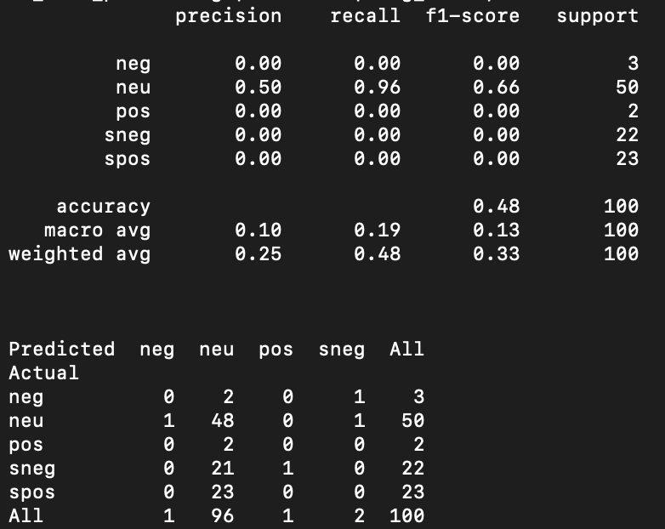

## Sentiment Lexicon

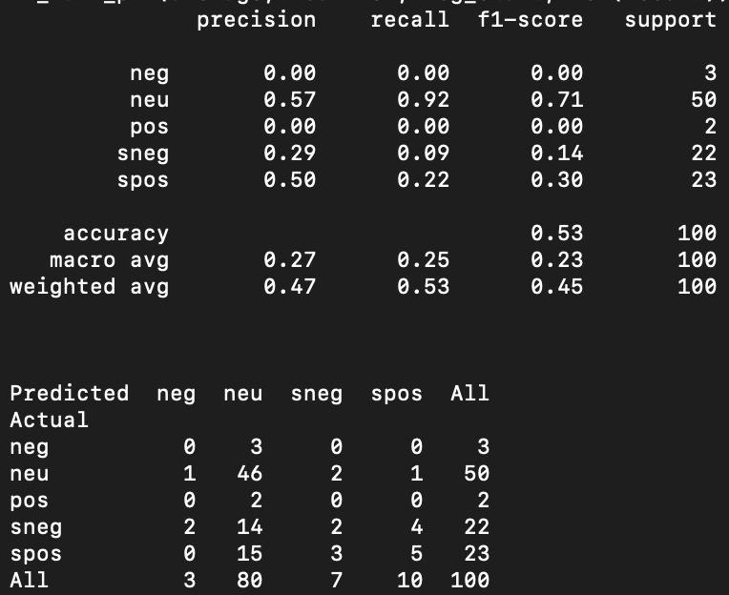

## NOT Features

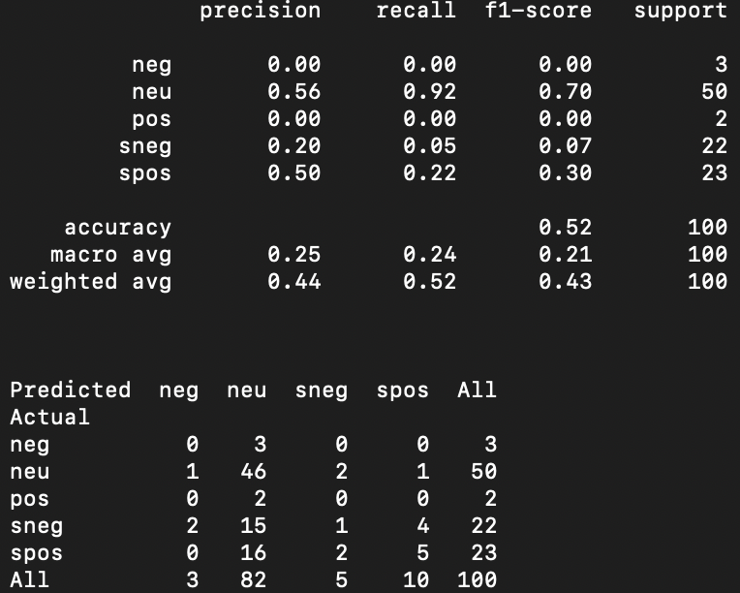

## POS Features

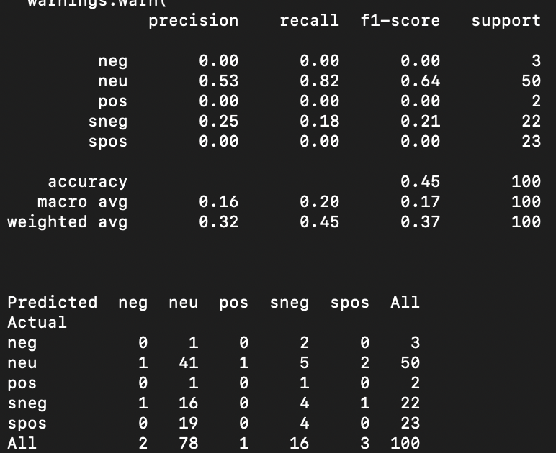

## Bigram Features

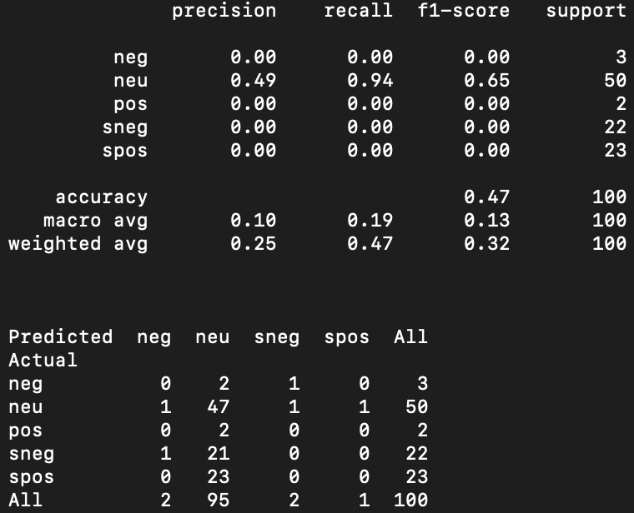

## Trigram Features

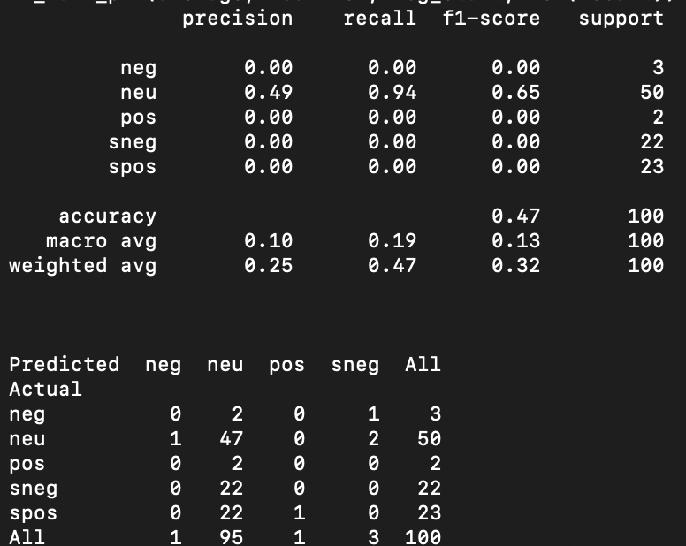

## Combined Features

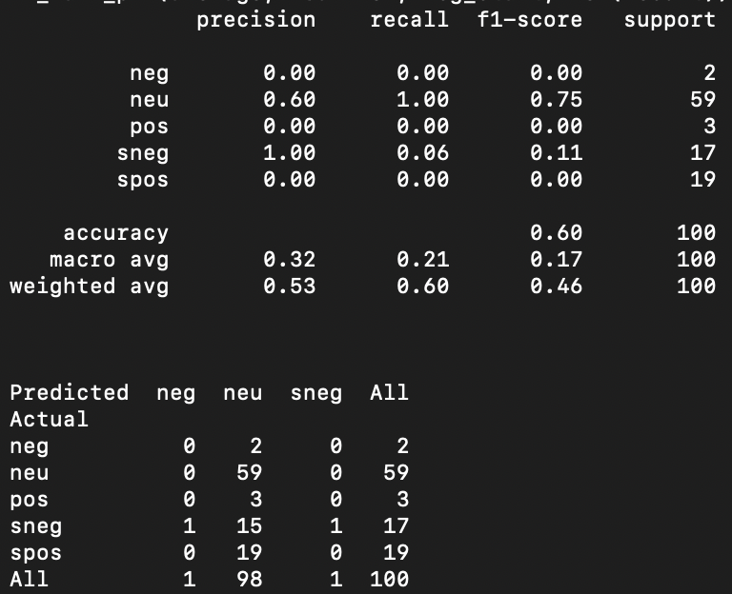

## Results & Observations:

|  |  |  |  |
| --- | --- | --- | --- |
| Decision Trees | | | |
| Feature Name | **Precision** | **Recall** | **F1-Score** |
| Without Pre-Processing | 0.42 | 0.45 | 0.37 |
| With Pre-processing | 0.25 | 0.48 | 0.33 |
| Sensitivity Lexicon | 0.47 | 0.53 | 0.45 |
| Negative words | 0.44 | 0.52 | 0.43 |
| Parts of speech | 0.32 | 0.45 | 0.37 |
| Bigram | 0.25 | 0.47 | 0.32 |
| Trigram | 0.25 | 0.47 | 0.32 |
| Combined | 0.53 | 0.60 | 0.46 |

The decision tree model generally performs better with features that provide more distinct and easily separable patterns in the data. The combined feature set likely provides a richer representation of the data, enabling the decision tree to make more informed splits and improve its overall performance.

# Experiments Summary

We have experimented with different limits on the NLTK Naïve Bayes classifier to see how accuracies are changing for different limits on different feature sets.

|  |  |  |  |  |
| --- | --- | --- | --- | --- |
| Naïve Bayes Accuracy Table | | | | |
| Feature Name | **Limit** | | | |
| **100** | **300** | **500** | **700** |
| Without Pre-Processing | 50% | 43.33% | 33% | 47% |
| With Pre-processing | 50% | 53% | 40% | 49% |
| Sensitivity Lexicon | 52% | 52% | 40% | 49% |
| Negative words | 50% | 52% | 40% | 49% |
| Parts of speech | 48% | 50% | 33.33% | 40% |
| Bigram | 50% | 52% | 45% | 49% |
| Trigram | 50% | 52% | 47% | 49% |
| Combined | 70% | 60% | 47% | 50% |

As the limit increased, we observed a corresponding increase in data variability, resulting in lower accuracies. To address this, it's imperative to develop more robust functions capable of maintaining high accuracies even with larger datasets.

While the combined feature set yielded superior accuracy, a significant drawback was the extended processing time required for generating these features. Therefore, to streamline our project exploration, we've decided to proceed with a limit of 100. This balance allows us to maintain reasonable accuracy while mitigating processing time constraints.

For our next experiments we have chosen Logistic Regression, Support Vector Machine, Decision Tree from the Sickit Learn Library to perform classification of the phrases on different feature sets. The below is the combined table of all the experiments performed so far.

|  |  |  |  |  |  |  |  |  |  |
| --- | --- | --- | --- | --- | --- | --- | --- | --- | --- |
| **Scikit Learn Model** | **Logistic Regression** | | | **Support Vector Machine** | | | **Decision Tree** | | |
| **Feature Name** | **Precision** | **Recall** | **F1-Score** | **Precision** | **Recall** | **F1-Score** | **Precision** | **Recall** | **F1-Score** |
| Without Pre-Processing | 0.48 | 0.49 | 0.48 | 0.46 | 0.5 | 0.47 | 0.42 | 0.45 | 0.37 |
| With Pre-processing | 0.37 | 0.45 | 0.38 | 0.35 | 0.45 | 0.36 | 0.25 | 0.48 | 0.33 |
| Sensitivity Lexicon | 0.48 | 0.49 | 0.48 | 0.52 | 0.52 | 0.49 | 0.47 | 0.53 | 0.45 |
| Negative words | 0.48 | 0.49 | 0.48 | 0.52 | 0.52 | 0.49 | 0.44 | 0.52 | 0.43 |
| Parts of speech | 0.36 | 0.39 | 0.38 | 0.32 | 0.4 | 0.35 | 0.32 | 0.45 | 0.37 |
| Bigram | 0.37 | 0.45 | 0.38 | 0.35 | 0.45 | 0.36 | 0.25 | 0.47 | 0.32 |
| Trigram | 0.37 | 0.45 | 0.38 | 0.35 | 0.45 | 0.36 | 0.25 | 0.47 | 0.32 |
| Combined | 0.51 | 0.55 | 0.51 | 0.43 | 0.5 | 0.45 | 0.53 | 0.6 | 0.46 |

1. Sensitivity Lexicon and Negative words features perform consistently well across all three classifiers - Support Vector Machine (SVM), Decision Trees, and Logistic Regression. They generally yield higher precision, recall, and F1-score compared to other individual feature sets, indicating their effectiveness in capturing sentiment-related information.

2. Pre-processing techniques generally led to a decrease in performance across all classifiers. This maybe because the pre-processing steps removed important information or introduced noise into the data, or simply because of the random phrases we have chosen for the experiment making it inconclusive.

3. Combined feature sets consistently outperform individual feature sets across all classifiers. This indicates that combining multiple feature sets can enhance the classifiers' predictive performance by capturing complementary information and improving their ability to generalize.

4. Parts of speech, bigram, and trigram features tend to yield relatively lower precision, recall, and F1-score across all classifiers. This suggests that these features may not be as informative or suitable for sentiment classification tasks, possibly due to the complexity introduced by these features and the classifiers' limitations in effectively handling them.

5. Among the three classifiers, Logistic Regression generally achieves higher precision, recall, and F1-score compared to SVM and Decision Trees, especially with the combined feature set. This suggests that Logistic Regression may be more suitable for sentiment classification tasks with the given feature sets and data characteristics.

# Advanced Task

We choose to perform this Advanced task where we will train the classifier on the entire training set and test it on a separately available test set.

The code in the image outlines two functions for processing text data:

1. **process_dataset**: Reads a dataset from a file, tokenizes each entry, pairs it with its label, optionally shuffles the data, and can limit the number of processed entries.
2. **create_featuresets**: Takes pre-processed documents and applies a feature extraction function to each document to create feature sets on the entire dataset.

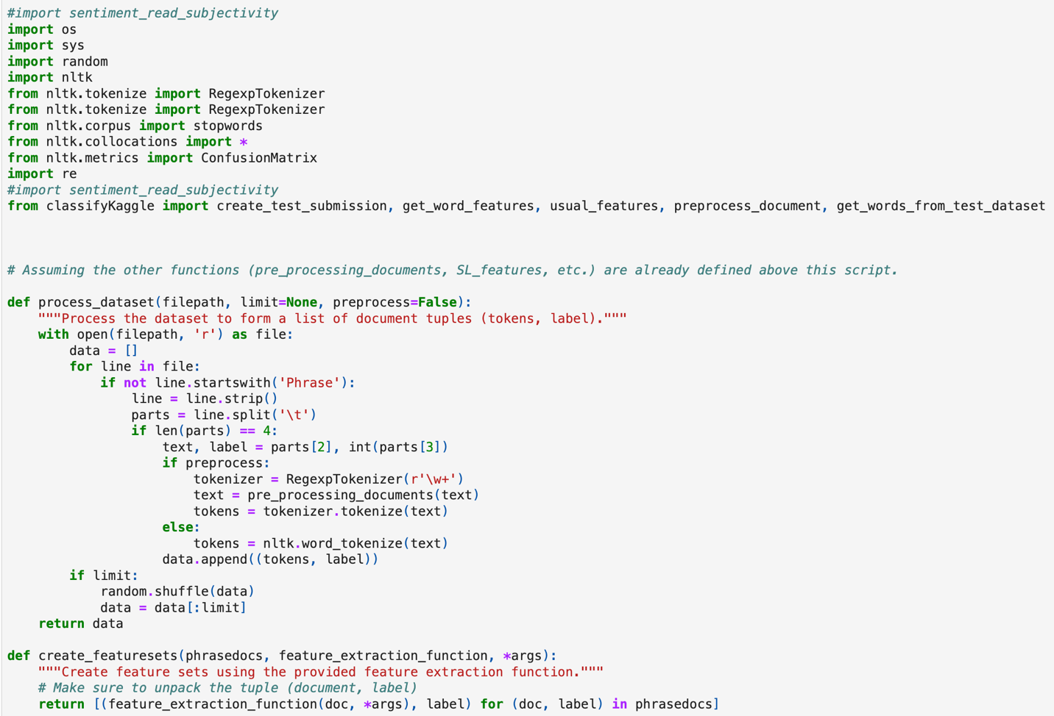

After features are extracted, we have created the following code to calculate accuracies of the NLTK Naïve Bayes model.

1. **accuracy_calculation**: Splits feature sets into a training set (80%) and a test set (20%), trains an NLTK Naive Bayes Classifier, calculates and prints the accuracy, shows the most informative features, and prints a confusion matrix.
2. **print_confusionmatrix**: Takes a trained classifier and a test set to produce and print a confusion matrix.
3. **main**: Processes training and test data, extracts features, trains the classifier, and performs the accuracy calculation.

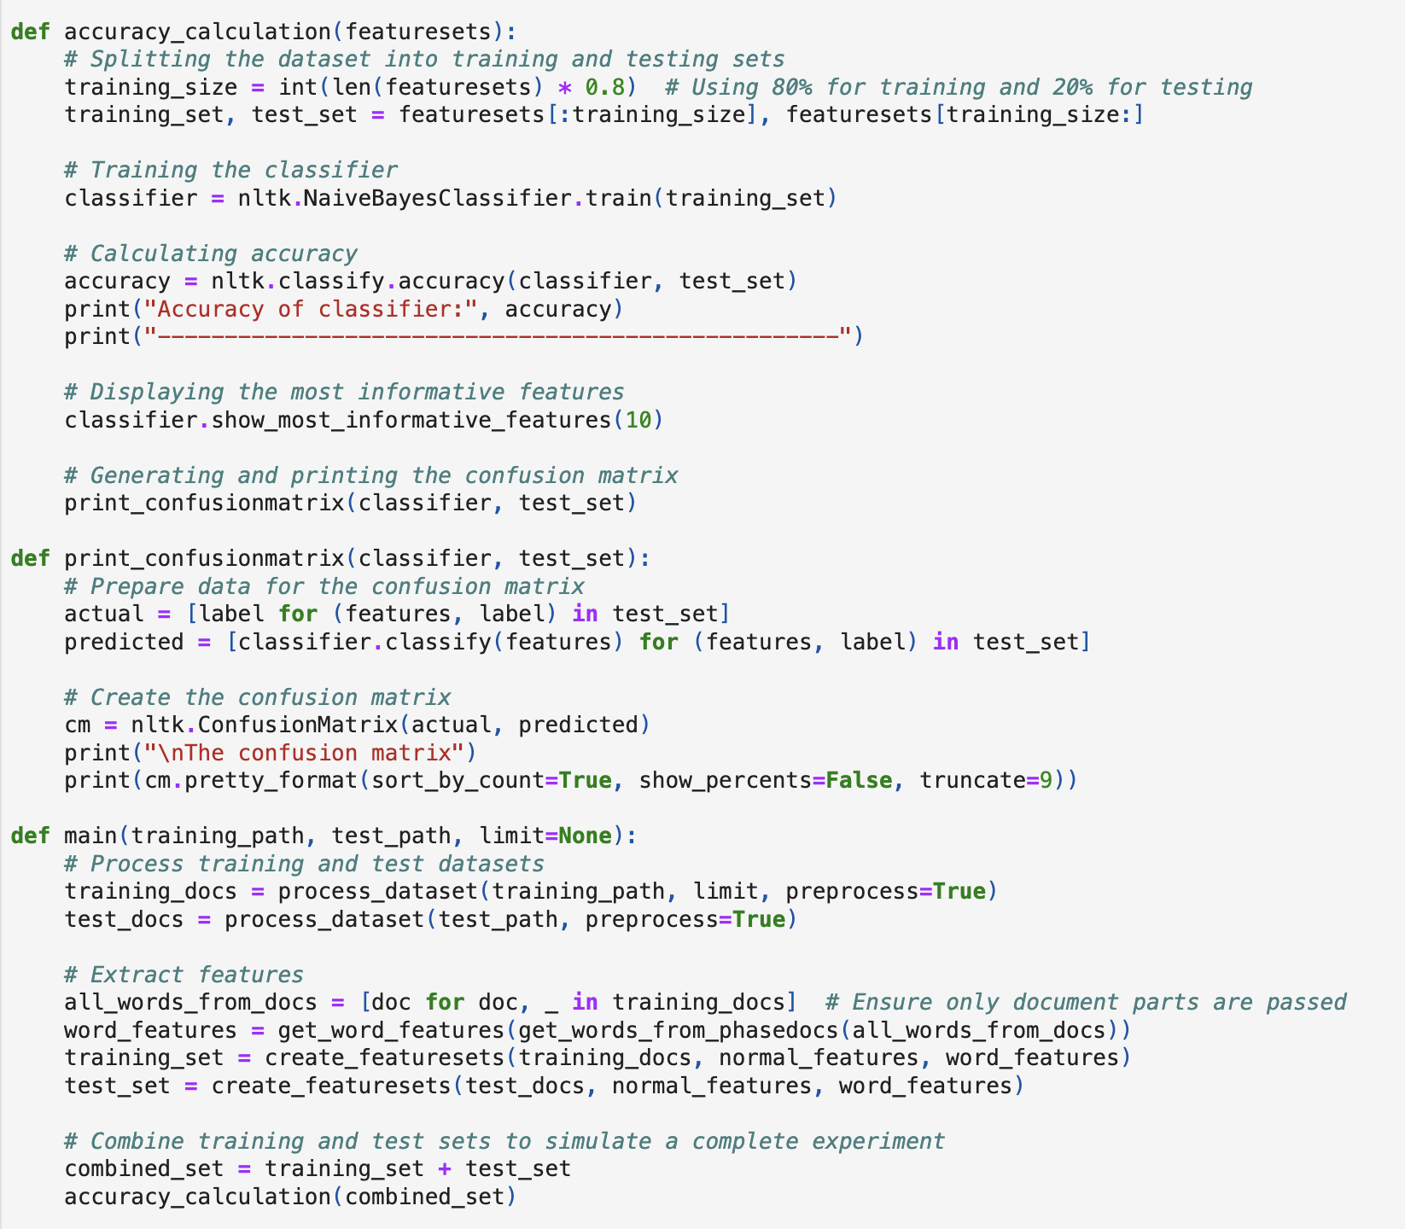

## Results & Observations:

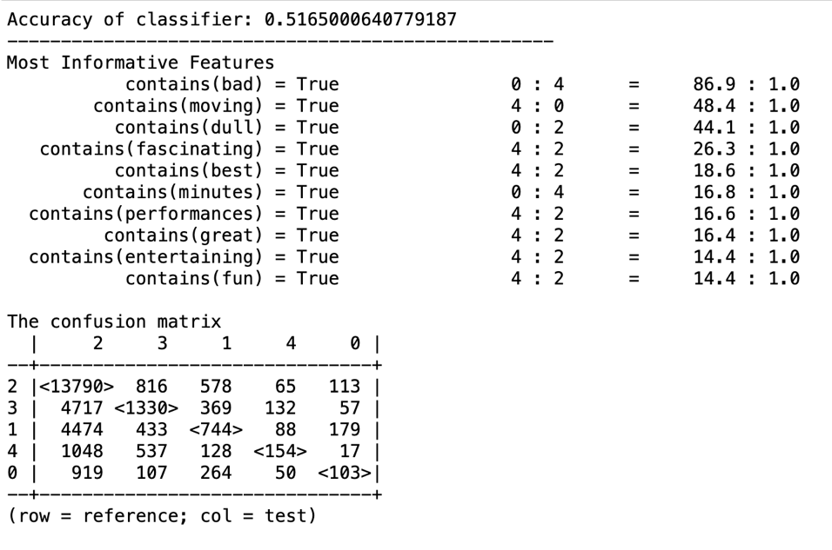

1. **Accuracy of classifier**: The classifier's accuracy is approximately 51.65%, which suggests that the classifier is correct about half the time. This decrease in the level of accuracy can be explained the data variability as the model is trained and tested on a large corpus.
2. **Most Informative Features**: The features listed (e.g., "bad," "moving," "dull") suggest that the classifier may be picking up on simple cues that are highly indicative of certain classes. However, the dominance of a single class (0) in the ratios for these features suggests a potential class imbalance or that the model is biased towards a specific class.
3. **The Confusion Matrix**: The confusion matrix shows a substantial number of instances along the diagonal (correct predictions), which is good. However, there are also many misclassifications, as indicated by the large numbers off the diagonal, especially between some classes (e.g., class 1 and class 2).

# Conclusion

In conclusion, our exploration of various machine learning models for sentiment analysis culminated in the selection of the Naïve Bayes classifier as the optimal choice. Achieving a maximum accuracy of 70% with combined feature sets, Naïve Bayes demonstrated efficiency in handling high-dimensional data and robustness to small datasets. Its ability to maintain reliable performance even in scenarios with limited training data sets it apart from other models like logistic regression, decision trees, and SVMs. Moving forward, the Naïve Bayes classifier will serve as the foundation for our sentiment analysis project, offering both accuracy and scalability in handling diverse text data.

# Lessons Learned

1. **Synthesizing Concepts**: We have managed to merge various concepts learned throughout the semester into practical implementations, providing a comprehensive understanding of machine learning.
2. **Python File System Utilization**: By leveraging Python's file system, We've streamlined code writing, enabling reusability and enhancing efficiency, especially when dealing with extensive datasets.
3. **Handling Large Datasets**: We've gained hands-on experience in addressing challenges posed by large datasets, refining our ability to optimize code for performance and memory efficiency.
4. **Impact of Feature Sets**: Experimentation with different feature sets has revealed their direct influence on model accuracy, emphasized the importance of thoughtful feature selection in model performance.
5. **Model Implementation and Comparison**: Implementing and comparing various machine learning models has provided valuable insights into their behaviour and performance, aiding in informed model selection and tuning decisions.
6. **Understanding Variability and Accuracy**: Through observation, we've grasped how altering certain parameters can introduce variability and impact model accuracy, underscoring the need for meticulous parameter tuning and evaluation.
7. **Addressing Class Imbalance**: We've observed firsthand how class imbalance can lead to fluctuating accuracies, highlighting the significance of employing strategies tailored for imbalanced datasets to ensure robust model performance.

# Work Distribution

|  |  |
| --- | --- |
| Team Member | Tasks performed |
| Anjana Sowmya Puvvada | Data Pre-processing, Tokenization, Naïve Bayes, Support Vector Machines, debugging, Documentation |
| Nikitha Chandana | Feature sets extractor, Logistic Regression, Decision Trees, debugging, Documentation |
| Prathyusha Murala | Advanced Task, Combined Feature extractor, Comparisons, debugging, Documentation |